* [Maximum Exposure Real Estate](http://docs.google.com/)
* [Remax #1 Real Estate](http://docs.google.com/)

[Massachusetts Real Estate Exposure](http://www.maxrealestateexposure.com/)

Real Estate MA & Home Sales

* [Home](http://docs.google.com/)
* [Raving Fans](http://www.maxrealestateexposure.com/contact/success-stories-testimonials/)
* [About Bill Gassett](http://www.maxrealestateexposure.com/about-maximum-exposure/)
  + [About RE/MAX Executive Realty](http://www.maxrealestateexposure.com/about-maximum-exposure/remax-executive-realty/)
  + [Contact Bill](http://www.maxrealestateexposure.com/contact/)
* [Buyers](http://www.maxrealestateexposure.com/greater-metro-west-ma-home-buyers/)
  + [Home Buying Costs Massachusetts](http://www.maxrealestateexposure.com/greater-metro-west-ma-home-buyers/home-buying-costs-massachusetts/)
  + [Massachusetts Homestead Protection](http://www.maxrealestateexposure.com/greater-metro-west-ma-home-buyers/massachusetts-homestead-protection/)
  + [What is Real Estate Title Insurance](http://www.maxrealestateexposure.com/greater-metro-west-ma-home-buyers/real-estate-title-insurance/)
* [Sellers](http://www.maxrealestateexposure.com/greater-metro-west-ma-home-sellers/)
  + [How to Interview a Realtor | Real Estate Interview Questions](http://www.maxrealestateexposure.com/greater-metro-west-ma-home-sellers/interviewing-a-realtor/)
  + [Home Staging & Home Sale Preparation](http://www.maxrealestateexposure.com/greater-metro-west-ma-home-sellers/home-staging-home-sale-preparation/)
  + [Home Selling Costs Massachusetts](http://www.maxrealestateexposure.com/greater-metro-west-ma-home-sellers/home-selling-costs/)
  + [How to Handle A Real Estate Offer](http://www.maxrealestateexposure.com/greater-metro-west-ma-home-sellers/handling-offers/)
  + [How Do Home Sale Contingencies Work](http://www.maxrealestateexposure.com/greater-metro-west-ma-home-sellers/home-sale-contingencies/)
  + [Massachusetts Smoke & Carbon Monoxide Detector Laws](http://www.maxrealestateexposure.com/greater-metro-west-ma-home-sellers/smoke-carbon-monoxide-detector-law/)
  + [Massachusetts Title 5 Septic System Law](http://www.maxrealestateexposure.com/greater-metro-west-ma-home-sellers/title-v-septic-system-law/)
* [Greater Metrowest MA Area](http://www.maxrealestateexposure.com/ma-re/)
  + [Middlesex County, MA: Real Estate Information](http://www.maxrealestateexposure.com/ma-re/middlesex-county/)
    - [Realtor Ashland MA | Real Estate Ashland Mass](http://www.maxrealestateexposure.com/ma-re/middlesex-county/ashland-ma-real-estate/)
    - [Realtors Framingham MA | Real Estate Framingham Mass](http://www.maxrealestateexposure.com/ma-re/middlesex-county/framingham-ma-real-estate/)
    - [Realtor Holliston MA | Real Estate Holliston Massachusetts](http://www.maxrealestateexposure.com/ma-re/middlesex-county/holliston-ma-real-estate/)
    - [Realtor Hopkinton MA | Real Estate Agents Hopkinton](http://www.maxrealestateexposure.com/ma-re/middlesex-county/hopkinton-ma-real-estate/)
  + [Norfolk County MA Real Estate](http://www.maxrealestateexposure.com/ma-re/norfolk-county/)
    - [Realtor Bellingham MA | Top Real Estate Agent Bellingham](http://www.maxrealestateexposure.com/ma-re/norfolk-county/real-estate-agent-bellingham-ma/)
    - [Realtor Franklin MA | Top Real Estate Agent Franklin Mass](http://www.maxrealestateexposure.com/ma-re/norfolk-county/franklin-ma-real-estate/)
    - [Realtors Medway MA | Top Real Estate Agent Medway Mass](http://www.maxrealestateexposure.com/ma-re/norfolk-county/medway-ma-real-estate/)
  + [Worcester County MA Real Estate](http://www.maxrealestateexposure.com/ma-re/worcester-county/)
    - [Realtor Grafton MA | Real Estate Agent Grafton Mass](http://www.maxrealestateexposure.com/ma-re/worcester-county/grafton-ma-real-estate/)
    - [Realtor Mendon MA | Real Estate Agents Mendon Mass](http://www.maxrealestateexposure.com/ma-re/worcester-county/realtors-mendon-ma/)
    - [Realtors Milford MA | Real Estate Milford](http://www.maxrealestateexposure.com/ma-re/worcester-county/milford-ma-real-estate/)
    - [Realtor Millbury MA | Top Real Estate Agent Millbury Mass](http://www.maxrealestateexposure.com/ma-re/worcester-county/real-estate-agents-millbury-mass/)
    - [Northbridge MA Real Estate](http://www.maxrealestateexposure.com/ma-re/worcester-county/northbridge-ma-real-estate/)
    - [Shrewsbury Massachusetts](http://www.maxrealestateexposure.com/ma-re/worcester-county/shrewsbury-massachusetts/)
    - [Realtor Southborough MA | Real Estate Southborough Mass](http://www.maxrealestateexposure.com/ma-re/worcester-county/southboro-ma-real-estate/)
    - [Realtor Westborough MA | Top Real Estate Agent Westborough Mass](http://www.maxrealestateexposure.com/ma-re/worcester-county/westboro-ma-real-estate/)
    - [Realtors Upton MA | Real Estate Upton Massachusetts](http://www.maxrealestateexposure.com/ma-re/worcester-county/upton-ma-real-estate/)
* [Property Search](http://www.maxrealestateexposure.com/property-search/)
  + [Ashland MA Homes For Sale](http://www.maxrealestateexposure.com/property-search/ashland-ma-property-search/)
  + [Bellingham MA Homes For Sale](http://www.maxrealestateexposure.com/property-search/bellingham-ma-property-search/)
  + [Framingham MA Homes For Sale](http://www.maxrealestateexposure.com/property-search/framingham-ma-property-search-2/)
  + [Franklin MA Homes For Sale](http://www.maxrealestateexposure.com/property-search/franklin-ma-property-search/)
  + [Grafton MA Homes For Sale](http://www.maxrealestateexposure.com/property-search/grafton-ma-property-search/)
  + [Holliston MA Homes For Sale](http://www.maxrealestateexposure.com/property-search/holliston-ma-property-search/)
  + [Homes For Sale Hopkinton MA](http://www.maxrealestateexposure.com/property-search/hopkinton-ma-property-search/)
  + [Medway MA Property Search](http://www.maxrealestateexposure.com/property-search/medway-ma-property-search/)
  + [Milford MA Homes For Sale](http://www.maxrealestateexposure.com/property-search/milford-ma-property-search/)
  + [Northbridge MA Homes For Sale](http://www.maxrealestateexposure.com/property-search/northbridge-ma-property-search/)
  + [Shrewsbury MA Homes For Sale](http://www.maxrealestateexposure.com/property-search/shrewsbury-ma-property-search/)
  + [Southboro MA Property Search](http://www.maxrealestateexposure.com/property-search/southboro-ma-property-search/)
  + [Westborough MA Homes For Sale](http://www.maxrealestateexposure.com/property-search/westboro-ma-property-search/)
* [Blog Articles](http://www.maxrealestateexposure.com/ma/featured-articles/)
  + [Featured Homes](http://www.maxrealestateexposure.com/ma/greater-metro-west-ma-featured-homes/)
  + [Market Reports](http://www.maxrealestateexposure.com/ma/greater-metro-west-ma-market-reports/)
  + [Real Estate Marketing](http://www.maxrealestateexposure.com/ma/greater-metrowest-ma-real-estate-marketing/)
  + [Home Buying](http://www.maxrealestateexposure.com/ma/metrowest-ma-home-buying/)

[Home (RE Exposure)](http://www.maxrealestateexposure.com) » [Featured Articles](http://www.maxrealestateexposure.com/ma/featured-articles/) » Questions to Ask a Listing Agent at an Open House

Questions to Ask a Listing Agent at an Open House

March 28, 2016 by [Bill Gassett](http://www.maxrealestateexposure.com/author/admin/) [Leave a Comment](http://www.maxrealestateexposure.com/questions-ask-listing-agent-at-open-house/#respond)

**156**

inShare217

## Key Questions To Ask At An Open House

 217 Anyone who is an avid reader of my blog probably knows that I am [not a big fan of open houses](http://www.maxrealestateexposure.com/the-drawbacks-of-an-open-house/). My perspective on the importance on an open house comes from what’s important when representing a seller. Frankly, open houses aren’t necessary to sell a home. A serious buyer will almost always schedule a showing on a property they are interested in viewing.

Most often open houses bring in people that a seller might not necessarily want in their home, including those who are not qualified to pay the asking price, a nosy neighbor or even something more nefarious like a thief. For most people none of these open house aspects are appealing, especially when they are not vital to selling a home.

For buyers on the other hand, an open house could be a convenient opportunity to get first hand information they might not otherwise get directly.

An open house provides a buyer with the opportunity to gather quite a bit of information on a home in a short amount of time. The listing agent often times will be present and ready to answer questions, which will allow a buyer to possibly get his or her full attention. The information needed to make an informed purchase might come immediately rather than waiting for a buyer agent to get back to them.

But what are the top questions to ask a listing agent at an open house? The following list should give you a starting point to draft your own personal list – so you can get right to the point when you talk to the listing agent.

### 1. Why are the owners selling their home?

Knowing why the sellers are moving can help you gauge how fitting the home and the area is for you. Of course, the agent may not be completely forthcoming if there are major issues – with the neighborhood, the home, etc. However, you can watch how the agent reacts and at least get an idea if there are serious problems, even if the agent doesn’t say so outright.

If you do notice hesitation or feel like the agent is not explaining clearly, it is worth stepping back and considering what possible problems might be. Your real estate agent can dig a little deeper and may be able to get a better idea of what is going on.

If you have dealt with enough real estate agents you may have noticed that some of them don’t know when to shut up. Sometimes an agent will give out information that really shouldn’t be shared. Keep in mind however, the listing agent is working for the seller.

It is that agents responsibility to show undivided loyalty, reasonable care, confidentiality, accountability and obedience to lawful instruction. Everything a sellers agent says and does should have their clients best interest at heart. Is it possible you could run into a knucklehead agent that does none of the above? Truthfully the answer is yes and that is a real shame.

One the other hand, when you ask why the owners are selling their home and a professional agent is present you probably will not get the full truth nor should you for the reasons mentioned above. For example working as a [Grafton Mass Real Estate agent](http://www.maxrealestateexposure.com/ma-re/worcester-county/grafton-ma-real-estate/), I have been asked numerous times over the years why a seller is moving. If I knew the reasons for the move was a divorce, I would never let a buyer know that! It doesn’t take much brain power to understand that a buyer having this information could impact what my client sells their home for. Buyers asking this kind of question at an open house should take the answer with a grain of salt.

### 2. Are there any problems with the home?

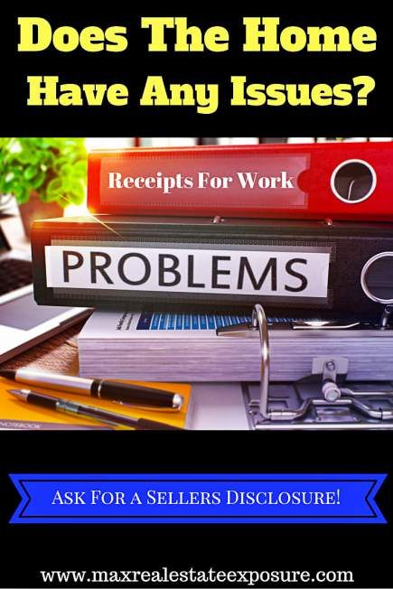 217 Another great question to ask at an open house is are there any known problems with the home. In most states the law requires real estate agents to disclose any structural problems or code violations to potential buyers. Any major issue that an agent is aware of that could effect a buyers purchase decision should be disclosed.  In many states however, sellers are not required to disclose problems when selling their home. They call this [caveat emptor](http://legal-dictionary.thefreedictionary.com/caveat+emptor) or “let the buyer beware”. This is a major reason why home inspections are a critical part of a real estate transaction.

You should request from the listing agent a written seller’s disclosure, which will list all such issues with the home. In most states seller disclosure statements are a regular part of conducting a transaction. The form will list everything the seller knows about their home both good and bad.

Depending on how transparent the agent is, you might learn of about issues you might otherwise not have noticed. Taking pictures or notes of any problem areas can be helpful later on when you are trying to determine your offer.

### 3. Have there been any changes in the price of the home?

The seller’s real estate agent can give you the low-down on any drops in the price of the home, and why the price dropped. This information can help you gauge whether the price is flexible, which may mean you can get the home for an even better price. If there have been multiple drops in the price, it is a good idea to look more carefully at the home and ask your agent about the situation. There may be issues that are not obvious on the surface, but that other buyers are noticing and that are keeping the home from selling.

Again sometimes an agent will say far more than they should when it comes to a question like this. For example over the twenty nine years I have been selling real estate, I can’t even begin to tell you how many times an agent as told me their clients are “extremely motivated to sell”. Often I am left wondering if their clients have given them permission to say this or they are taking matter into their own hands. Frankly, I bet it is the latter more times than not.

### 4. What are the average utility costs?

Depending on the size of the home, the HVAC system and [how energy efficient the home is](http://www.maxrealestateexposure.com/home-energy-audit/), you may be looking at a much higher utility bill than you are used to. Ask to see utility bills so you can get an idea of what your costs will be. Utilities can be costly in certain homes, and are an expense that you should include in your calculations for what you can afford over the long-term. This is in fact one of the things I recommend to my sellers clients to have left as part of the [real estate marketing material](http://www.maxrealestateexposure.com/10-overlooked-items-help-market-home/) for the home. Most buyers are going to ask for it anyway do you might as well have it available.

### 5. How long has the home been on the market?

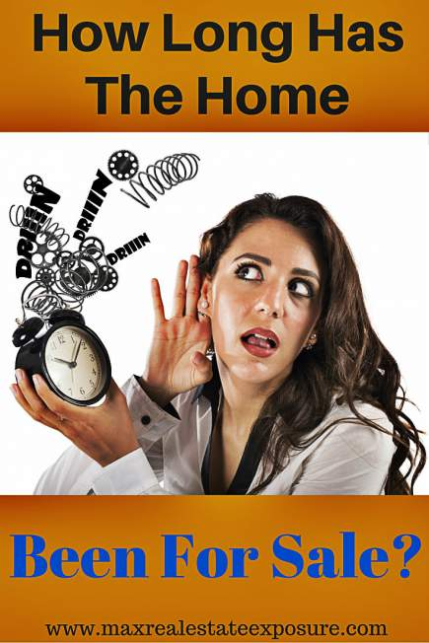 217 You and your real estate agent can find this information on your own, but the listing agent may give you more insight into how long the home has been on the market and why. If a home is listed for too long, it often becomes harder to sell, which can give you bargaining power. You may find that the home has only been for sale a short while, but that buyers are expressing a lot of interest – in which case you may need to make an offer if you want to get the house for yourself.

How long the home has been on the market is probably one of the most common questions a buyer will ask. It is also a major reason why real estate agents are constantly counseling their clients about [pricing a home correctly from day one](http://www.maxrealestateexposure.com/factors-to-consider-when-pricing-a-home-for-sale/). Getting to the bottom of why a home has not sold is always important. While price is the main reason why homes don’t sell, there are underlying factors as to why homes can only command a certain price. For example if a home is located in close proximity to a noisy highway it is certainly going to be worth less than a similar home in a nice neighborhood without any noise.

### 6. Have there been any offers on the home?

Usually listing agents are excited to let you know that one or more offers have been made, because it can spark a bidding war and drive up the final sale price. If you are interested in the home, you definitely want to be aware if there is any competition. If the home has been on the market for a while understanding whether there has been an offer in the past may also be helpful to know. Maybe the owner should have taken an offer right out of the gate and are now kicking themselves that they didn’t do so. Who knows their motivation to sell quickly may also have changed.

### 7. What kind of timeline is the seller aiming for?

Knowing what the seller’s plans are can help you plan your own strategy. The seller may want to move quickly, in which case the price might be more flexible. Or the seller may not be in any hurry, which might mean that he or she is not as apt to bargain with you. It is also possible if you grant the sellers request for an extended stay you might get a better price. It is always important to find out what the hot buttons are for a seller.

### 8. How is the neighborhood?

Living in a home is about more than just the physical property. You definitely want to have an idea of what the area is like, particularly the surrounding neighborhood and the neighbors living closest to you. Knowing [how to pick a neighborhood](http://www.maxrealestateexposure.com/neighborhood-details-to-consider-when-buying-a-home/) that suites your lifestyle is always an important consideration. Sometimes retirees or families prefer to live next to other people in a similar stage in life. Younger buyers might want an area where it is easy to walk to restaurants and bars. Almost everyone will want to know where the closest major shopping center is located.

Asking about the neighborhood can give you a good idea if it will fit with your lifestyle. The article above will also give you some important considerations to think about when buying into a neighborhood. Buyers often think about the home far more than the area and later regret their choice.

### 9. Have their been any renovations or updates made to the home?

You may not have any trouble seeing that the house has new appliances, but other updates – or lack of updates – can be harder to spot. As a buyer you need to know how old the roof is, for instance. With older homes you may want to ask about the electrical system. Fundamental aspects of the home like a roof or wiring are expensive to update, so you want to be aware if you as the new owner should expect to pay for them at some point. When representing home owners I often recommend for them to put together a [list of improvements to help market the home](http://www.maxrealestateexposure.com/improvements-that-will-help-sell-your-home/). These items can be super important because they speak to how much a home should be worth. It gives a buyer piece of mind when they know the major mechanical systems in a home have been updated.

### 10. Where do the current owners enjoy shopping, eating, etc?

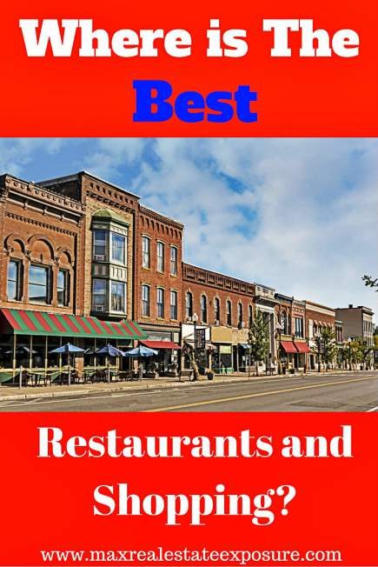 217 Just as knowing about your potential neighbors is important, so is knowing what stores and restaurants are near the home. After you get the basics about what the current owners or listing agent likes about the area, you can take your own trip and get a feel for what it would be like going out to eat and shopping if you lived in the home. This may be another smart [consideration for choosing a neighborhood](http://www.maxrealestateexposure.com/what-to-look-for-when-searching-for-a-neighborhood/). While the listing agent may not know what the sellers preferences are for local eating and shopping they might have their own opinions that could be useful.

#### Bonus Questions to Ask The Listing Agent During The Open House

Here are some additional questions you can ask the listing agent at an open house that would be important to find out.

* Has there ever been remediation done for mold in the home?
* Has the home been tested for the presence of elevated radon levels?
* Did the current owner test for the presence of lead (if the home was built prior to 1978).
* Is the home located in a [flood zone](https://msc.fema.gov/portal/search)?
* Has an underground oil tank ever been present at the home?
* Was asbestos ever removed from the home?
* Did the [seller get permits for the addition](http://www.maxrealestateexposure.com/the-importance-of-getting-permits-for-additions-and-improvements/) or work they did to the home?
* Are there any know sex offenders living in close proximity to the home?

#### Final Thoughts

Hopefully these *questions to ask a listing agent at an open house* have been helpful. Use the opportunity to learn what you can. Who knows you may get more information that you ever expected if the real estate agent has loose lips. Use this to your advantage in negotiating the best deal possible.

#### Other Important Open House Resources

* The [real reason real estate agents hold open houses](https://www.behance.net/gallery/34965527/Why-Do-Real-Estate-Agents-Hold-Open-Houses) via Behance.
* [Why open houses don’t help unrepresented buyers](http://www.caare.org/OpenHouse) via Consumer Advocates in American Real Estate.
* [Are open houses worth it](http://www.maxrealestateexposure.com/do-real-estate-open-houses-work/) via Maximum Real Estate Exposure.
* The [pros and cons of holding open houses](http://www.rochesterrealestateblog.com/the-pros-and-cons-of-open-houses-in-real-estate/) via Rochester Real Estate Blog.
* [Get the most out of an open house](http://www.wendyweirrelocation.com/making-the-most-of-an-open-house-visit/) visit via Wendy Weir Relocation.

Use these additional open house resources to help in your journey to either buying or selling a home! See some of the pros and cons of open houses you may not be aware of.

About the Author: The above Real Estate information on the questions to ask a listing agent at an open house was provided by Bill Gassett, a Nationally recognized leader in his field. Bill can be reached via email at [billgassett@remaxexec.com](https://mail.google.com/mail/?view=cm&fs=1&tf=1&to=billgassett@remaxexec.com) or by phone at 508-625-0191. Bill has helped people move in and out of many Metrowest towns for the last 29+ Years.

Thinking of selling your home? I have a passion for Real Estate and love to share my marketing expertise!

I service Real Estate sales in the following Metrowest MA towns: Ashland, Bellingham, Douglas, Framingham, Franklin, Grafton, Holliston, Hopkinton, Hopedale, Medway, Mendon, Milford, Millbury, Millville, Northborough, Northbridge, Shrewsbury, Southborough, Sutton, Wayland, Westborough, Whitinsville, Worcester, Upton and Uxbridge MA.

**156**

inShare217

Enjoy This Real Estate Article?

"Subscribe To My Blog - It's FREE and No Spam EVER!"

Get my blog articles in your inbox as soon as they are published!



Filed Under: [Featured Articles](http://www.maxrealestateexposure.com/ma/featured-articles/), [Metrowest MA Home Buying](http://www.maxrealestateexposure.com/ma/metrowest-ma-home-buying/)

# About Bill Gassett

Bill Gassett is a nationally recognized Real Estate leader who has been helping people move in and out of the Metrowest Massachusetts area for the past twenty nine plus years. He has been one of the top RE/MAX Realtors in New England for the past decade. In 2015 he was the #5 RE/MAX real estate agent in New England. Connect with him on [Google+](https://plus.google.com/110779935325706809622)

Leave a Reply [Cancel reply](http://docs.google.com/questions-ask-listing-agent-at-open-house/#respond)

Your email address will not be published. Required fields are marked *

Comment

Not signed in

Name *

Email *

Website

Copyright © 2016 ·Bill Gasset | Return to Top ↑

Massachusetts Real Estate exposure is a marketing site designed to give Massachusetts home seller’s a dominant online presence. Massachusetts Real Estate Exposure is owned and operated by RE/MAX Realtor Bill Gassett, who covers the Metrowest Massachusetts area and beyond including Ashland, Bellingham, Blackstone, Framingham, Franklin, Grafton, Holliston, Hopkinton, Hopedale, Medway, Mendon, Milford, Millbury, Millville, Northborough, Northbridge, Shrewsbury, Southborough, Sutton, Wayland, Westborough, Worcester, Upton and Uxbridge MA. Bill Gassett has been one of the top RE/MAX Real Estate agents in New England over the last decade plus. In 2015 he was ranked as the #5 RE/MAX Real Estate agent in New England.

Search templates (CTRL+Space)

New Template