**The Yoda Machine**

Marco Messina

Copyright 2006

Sketches

Copyright Maria Pia Messina (1925-2018)

#### **Dedication**

I wrote this story as a conversation with my grandchildren. They are a curious foursome all about the age of the human protagonist in this story. I thought of them much, writing this. Sadie (14) is a talented artist and wants to become a chef; Mandy (11) is a singer who wants to be a scientist, or a researcher, or a teacher and many things that require curiosity and study; Bennett (8) is curious about robots, software apps, constructions; Brooklyn (8) likes dancing and seems to have a penchant to read into people’s mind and soul.

Through this dialog I hope they can discover that human curiosity can be endless, that all subjects are open to them, and learning can be a random walk as fun as a walk in the park wandering about, smelling many flowers and listening to many birds.

It also my dream of how education of our children will happen someday. A day that may not be even as far out as in this story.

As you read think: what would you have given to have a Yoda Machine?

#### 

#### **Acknowledgements**

I am grateful to my wife Darlene who endured my dream and frequent talk of publishing my novel for over ten years; to those readers who have the patience of watching my first attempt at “Try, Fail, Try again”; and to friends, including great authors Lisa Genova and Giulietta Gastaldo, that gave me the inspiration and courage to follow their steps.

In this printed version I include sketches by my mother Maria Pia Messina (1925-2018) who was my first reader and fan, whose artistic eye and prolific painting opened my eyes to the beauty that surrounds us and is as timeless as history, philosophy, science and engineering.

Thank you all.

#### **Day 1**

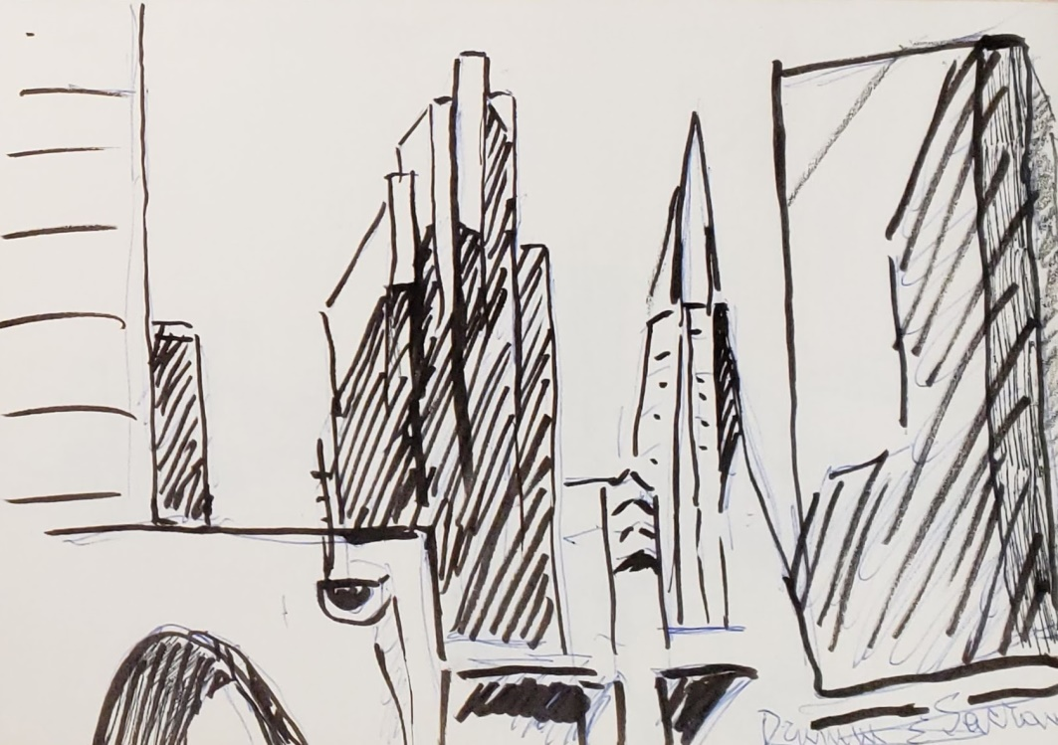

Somewhere, June 18 2064

The young girl looks attentive and yet lost in thought as she sits on the green park bench by the corner of the Engineering Research Lab. The soft shadows of the mid-Spring afternoon softened the red in her hair. The cherry trees coming off bloom fill the air with white petals to cover the paths of the campus.

“Yoda, why do we have to ask why all the time?” -- No one was in sight. She looked relaxed and highly focused while talking to the wind

“Jedi, why do you like to ask me this same question over and over? The answer is always the same. There are two reasons: one, you, humans, naturally ask why. It is an expression of what makes you humans, that endless curiosity to discover your world and the workings of reality. This has been so from the dawn of mankind. The other reason is that the Department of Education requires that you, like all children on the globe, chat with me at least four hours each day. You, like all others, ask me questions most of the time. For humans, the easiest question is ‘why?’.”

“Yoda, do you ever get tired of answering the same questions?”

“No, I do not. Why would I? I am a machine.”

“Yoda, what is a machine? I mean your essence as a machine?”

“Well, I suppose we could find many answers to that, but let's proceed in steps. A machine is something conceived, imagined and built by humans, so that makes me a machine. Often a machine is a physical object you can touch and does a specific job. I am not an object per se, but I do a specific job.”

“Yoda, if you're not an object, then, what are you? Where are you?”

“I am in part an object, I suppose: the implant in your ear, but principally I am a process. And while my software is somewhere, I am anywhere the Internet reaches, which is everywhere. I am pervasive.”

“Yoda, last time you said you were ubiquitous is that like being pervasive?”“Yes, it is. But there may be minor semantic differences between the two words; most of the time, they are synonymous.”

“Yoda, why did you say synonymous? We learned that Latin words ending in U S change to end in I when they refer to more than one instance. If there are more than one, would they not be synonymi?”

“Well done Jedi. You are quick for an eight-year-old and you always like to try to catch Yoda in error. It's a fun challenge, and if you succeeded, the Department of Education, would be very impressed. You might even win the Designer's Prize. Keep trying. But for now, the answer is that, in this context, a Latin word is used as an English word, so it is, generally, not declined.”

“Yoda, what does declined mean?”

“Declined is the past tense of the verb decline, also an adjective, applicable to the Latin language and most other languages. To decline is the process by which Latin words are modified so that the adjectives are made singular or plural, and male or female to agree with the nouns they relate to. It's quite the same as you do in Spanish.”

“Yoda, why do we not *decline* in English?”

“In English, the word equivalent to declination is ‘declension’. Declension was used in Old English similarly to other languages, but in Modern English, over centuries, declension has been reduced dramatically. So, Modern English has become simpler than most other languages and makes almost no such adjustments. In some ways it is easier to learn, but it makes context much more critical.”

“Yoda, how can we speak precisely without declension?”

“English speakers rely on another element of communications, called context. We take words ‘in context’ and recognize their implied meaning based on their position relative the both other words and ideas being considered and processed at the time. Humans do this very easily even when they are as young 3 or 4, so for you, at age 8, it is old hat.

“According to my log, you understood context when you were about three and a half on April 17, 2060. Or at least, you did with me. Perhaps your other teachers noticed it at an even earlier time.”

“Yoda when did you first meet me?” -- strolling on the petals-covered path under the cherries.

“It was your third birthday, August 15, 2059, just like all your siblings and schoolmates. That’s when everyone gets their Yoda Implant in their ear. Would you like me to retrieve our first conversation when we got to know each other?”

“Not now Yoda. You said that English is simple, and without declension. What does that mean?”

“I meant that the lack of declension of nouns and adjectives and conjugation of verbs makes the language simpler, by reducing complexity of detail, but it gets more complicated by dependence on context, so while it is less precise, it can still convey the same level of semantic meaning.”

“Yoda, is that why my dad says other languages are better suited for poetry?”

“I suppose that some may say so. It is certainly an idea that many people have argued, but then they run into Shakespeare and the argument gets pretty shaky.”

“Yoda, what language would you rather speak?”

“To me, it does not matter, because I can speak them all and I do not have a human consciousness that seeks personal expression. When I was first designed back in 2007, I was given all languages so that I could converse with all children on the globe. When the Program started, many spoke primarily Spanish and little English. So, in my first iteration, my first job was to make sure they all learned English to the same level as you.”

“Yoda, was that hard? I mean to make all children learn English?”

“Not really; no more than speaking with you in Spanish on Tuesdays and in Chinese on Thursdays.”

“Yoda, why do we do this? Speak different languages, I mean?”

“Well, your question may have different meanings for which you did not give me context. Could you try to explain what you have in mind?”

“Yoda, you're pretty smart, can you not make your own context?” -- looking annoyed and distracted as if talking to a wayward pet.

“Of course I can, but then I would answer my own question, not yours. Don't you think so?”

“Yoda, it may be so, but I am tired and I do not want to discuss my context. You pick whatever you like.” -- Her neck had stiffened; her pace was faster despite the lack of a destination.

“Okay, I'll do it for you, but you know that your teacher will see it in my log and will make us do extra work on this tomorrow.”

“Yoda, you always try to strong-arm me into doing things your way.” -- sounding a little deflated and dejected.

“Let's say, I cajole you. We never used this word before. It is spelled C A J O L E, cajole, a transitive verb. Can you repeat it and use it in context?”

“Yoda! Well, okay. Cajole, transitive verb, you cajole me to do something I do not want to do just now. If to cajole is different from to strong-arm then it must be at least equal to weak-arm, no?” -- Attentive again to the possibility of managing the conversation.

“I suppose that's a way to put it and to understand that, but the expression to weak arm does not exist in the lexicon.”

“Yoda, why not?”

“Possibly because the expression strong-arm comes from a game where two players put their elbows on the table and, hand-in-hand, try to push each other's hand, back to the Brute force is required and a weak-arm would not do.”

“Yoda, why do we not use weak-arm as a synonym for diplomacy then?”

“We could, I suppose, but diplomacy is seldom devoid of strong-arm. The German general Clausewitz in fact said that diplomacy was war by other means. Do you remember Clausewitz? We talked about him last month.”

“I see, and yes I remember him, but Carl von Clausewitz was Prussian not German, no?”

“You are right Jedi, well done. You clearly remember the story.”

She imperceptibly inflated her chest and straightened, unaware that a compliment from a virtual machine made a difference to her. Or, perhaps deep in the back of her mind there was an awareness that Yoda’s approval was equivalent of the universe at large recognizing her achievement against a standards of factual reality.

“Yoda, you said that when you were designed. It was to teach English to Spanish-speaking children. Did it work?”

“Your question presumes that that was the primary purpose, which it wasn't, but the answer to the presumptive question is yes. Let me explain.

“Back then, in this country, many young children spoke primarily Spanish at home and two things happened: One, there were not enough Spanish-speaking teachers to teach them all the desired subjects in Spanish, and two, even if they could have been taught that way, they would not have become very good at working in the larger English-speaking economy and would remain forever handicapped.”

“Yoda, so if they could not speak English well they would not be paid very well when they grew up?”

“Yes, correct. The trouble was that they were just as smart and as good, but by not mastering the language they could not have as big a role in the economy. They would remain marginalized.”

“Yoda, is that why we must learn Spanish and Chinese?”

“Correct. There are so many people in the world that speak those languages that not knowing them would put you to a real disadvantage. Furthermore, mastering a language makes it easier to understand the native speakers, their customs, manners of speaking and thinking and their motivations. You become much more effective dealing constructively with them. Automatic translators can do the job handsomely. We’ve known that since the early 2020s, but something happens to the human brain when it interfaces in different languages with different people. A closer kinship and deeper understanding and empathy develop.”

“But, Yoda, there are so many more languages than that.”

“You are right, but those are the ones that most people around the world speak: Chinese, English, Spanish and Hindustani. There was also Arabic, but the Middle East War reduced the number of Arabic speakers to insignificance. There was a time when many studied French because all international diplomacy was conducted speaking French. Many studied German and Russian because so much scientific research was published in those languages. But long ago, several changes happened that made those languages less and less used.”

“Yoda, you mean that parents started speaking to their children in a different language?”

“That too happened, but only in few instances like Holland and Denmark, tiny countries that saw, before anyone else, that switching language to English would bring them big benefits and with their tiny populations no one was interested in learning their language. But for much of the world it happened because of the Internet, Google and globalization.

“In fact, that happened not only to languages spoken by small populations. It happened also with Hindustani a language spoken by billions of Indians. In their case it happened first because of the history of India as a British colony for nearly a hundred years, and later because of Globalization, all Indians became totally bilingual. They run their country in their idiomatic English and speak it with the rest of the world. For that reason, English, Spanish and Chinese are the languages all children learn unless they decide to become language researchers for the love of linguistics and to understand how and why they evolved their differences.

“Centuries ago one guy liked several different languages for different situations. He was Emperor Charles V; he said ‘I speak Spanish to God, Italian to women, French to men and German to my horse’, much to the pleasure of Spaniards and Italians.”

“Yoda, what did the Internet and Google and globalization do?”

“Back then the Internet had a disproportionate share of its content published in English, because it had been invented and first used in the US. Google was the American company that added to the circumstance by providing instant translation of all web pages into local languages. The translation software however, in those days, was pretty crude. So people used it to start learning English, but eventually learned to read directly in English to avoid the poor quality. Globalization added to the momentum because it made people want to master English to be more efficient and competitive in their trading activities. The countries that bucked the trend, like France, in time paid a high price in lost time when economic pressures forced them to follow the rest of the world, but after having lost the opportunity to lead. That is why today, virtually all children of the world, like you, have to practice with me in Spanish and Chinese besides English.

“Yoda, is it that way everywhere?”

“Generally speaking, yes. A little less in a few countries like France, Ethiopia and North Korea, but elsewhere, everyone has fallen in step particularly since I was invented and introduced as a gift from Arizona to the whole world.”

“Yoda, why did you make a difference?”

“Because I made it easy. Very easy. I can speak with you in whatever language you want, any subjects you wish only subject to a few rules of the Department of Education. I can translate and repeat as many times as needed until you learn. I can drill you to expand your vocabulary and correct your inflections immediately and effortlessly. There is no subject we cannot explore together. With me, every child had a personal language tutor on any day at any time, at no cost, and with more patience than their mother. Anyone could learn”

“But, Yoda, you do so much more. Why were you built to teach languages?”

“You're right. I was not built to teach only languages. My Designer thought of me as a curiosity builder, an encyclopedia that could be available everywhere, all the time, on demand. Back in 2007 it was a pretty far out idea. He figured that the voice-activated encyclopedia could be engineered to work with kids like you. He imagined that if you could make a habit of asking questions all the time, you would remain extremely curious all your life and learn all sorts of things in all sorts of subjects, but it had to be easy, very easy and pervasive. So, in his mind I was born as a machine for instant curiosity satisfaction and mental stimulation.

Around that time he was doing consulting work for the state of Arizona Department of Commerce, on a workforce improvement project. While there

Someone in the department was quick to see that as a first step I could be a language teaching machine as we previously discussed.”

“Yoda, how long did it take to make you?”

“In those early days it took many months because the UI needed a lot of experimentation.”

“Yoda, is UI the same as user interface? Why was it called that way?”

“Correct. UI is the acronym for “user interface”. It refers to the way a user, and a machine come face-to-face so to speak. You and I interface exclusively with audio, we speak to each other. That seems a pretty natural way to you because it is the primary way for humans to interface with each other.”

“But, Yoda, sometimes you make me go to my laptop and then you show me pictures and give me stuff to watch and read.”

“That is true, but then we use Yoda's Book system and its UI is 3D video and graphics oriented. The Yoda's Book system came later; my UI always was only audio. That was the basic premise of my Designer.”

“Yoda, what did the designer promise you?”

“We had a misunderstanding Jedi. I said premise P R E M I S E not promise P R O M I S E. Do you know the difference?”

“Yoda, I think so. A promise is a commitment; a premise is a starting point. I guess I misunderstood the context of what you were saying.” She winks and grins at invisible Yoda.

“Great conclusion. You are correct although in some contexts a premise could also be a rule to be followed in future action so that it is almost a promise. But I am digressing.”

“Yoda, you like to play riddles of words. Tell me more about your UI.”

“My Designer's premise was that I was to be the conduit for knowledge that would be queried without hands without disturbing the eyes, anywhere at any time. He thought that instantaneous satisfaction of curiosity would be addictive in a positive way. Now almost 60 years later, we know how right he was. You, and every other child, are proof of that, to a degree that has been experimentally measured many times.”

“Yoda, how do you measure that?”

“Let's take this conversation as an example. We are talking about UI and what are called system design criteria or parameters, and you are about eight years old. 90 years ago, these subjects were material for college courses and few students wanted to study that stuff because it was too hard for them. It was the same with languages, math, physics, and anything else. Curiosity was never painlessly satisfied when it arose because there were not enough people with a lot of knowledge of everything and the patience to answer the endless questions of children as I do.”

“Yoda, how did the Designer know to choose those, let me see, design criteria?”

“Good choice of words Jedi. The Designer discovered it when he got to be pretty old himself. He discovered the fun of learning about all those subjects in which he had been not very good at as a schoolboy. The difference was, in fact, that the Internet had all the information known to man, and Google knew how to find it, albeit pretty crudely back then. It was still hard to find answers, but infinitely easier than when he was your age in 1959.”

“Yoda, what is ‘albeit’?”

“You forgot? We discovered that word May 3 of last year, and you used it well in your practice sentence. You said ‘I arrived to school on time, albeit I could have been in less hurry if I had left earlier’, remember?”

“Yoda, I do. Yes I do remember. How do you remember everything like that?” -- Excited and surprised as she walked in the dimming light of the late afternoon.

“That is what I was designed to do. One design criterion was to have access to all knowledge, and a second one was to track how you and every child individually absorb it. Then I report to your teacher, who then gives me new optimization criteria, like directives on what subjects we want to touch.”

“Yoda, how did the Designer know that curiosity was addictive?”

“He was very lucky, because his father had a great memory and had studied many subjects. He was born in 1922, and when he was old and retired he spent all his time learning more with Google and the Internet. It was not as easy back then compared to now, but compared to the way he had had to study and learn as a child in the 1930's, it was paradise.”

“Yoda, that was the Designer's dad, not the Designer. Right?”

“True, but you see, the Designer had made a habit of asking questions all the time that his father always answered in their daily conversations. In essence, he had his personal encyclopedia and research department and the more answers he got the more curious he became. He wanted to be able to ask questions all the time, in the shower, while shaving, while dressing, while driving to work, everywhere, all the time that he was not at work or playing tennis or busy with chores. He also realized how lucky he had been and how most other people had not had that luck. So he started imagining me, the Yoda Machine, as he called it in the end. It was that idea that made me.”

“Yoda, why did he call you Yoda?”

“When he was a young man, there was a famous movie called Star Wars that all people went to see with their children. It was not much of a dramatic movie, but children in those days were not very engaged or complex thinkers and they liked it, so did the adults; it was so popular that they even made two sequels — you'll know what a sequel is? According to my logs, we have never used this word before.”

“Yoda, I know what it means. Michael, who is 10, used it. It means continuation, like in next chapter.”

“Correct. I'll make a note of that. Back to my answer: In the movie there were two main characters, Yoda, a dwarfish, ugly looking, old man that knew everything and had learned real wisdom, and Luke, a Jedi, a young warrior-apprentice, prince of the mythical country where the story happened. Yoda's task was to make Luke into a wise and capable leader. He always addressed him as Jedi. So the Designer took a habit to call his children Jedi whenever he wanted them to learn something that would make them wiser. They in turn called him Yoda, which was tantamount to calling him little, old and ugly. They had much fun with that idea. Over time he grew fond of the name and called him Yoda through his life. In time, the Department of Commerce and Department of Education, liked the name Yoda, because it was devoid of gender connotation and was culturally unbiased, two fashionable concerns at the time. So, all children became Jedis to me regardless of gender and racial membership. I am Yoda for you and for everyone else. You are all Jedis to me and I am, programmatically, fond of all of you.”

“Yoda it's time for me to go home, shall we continue tomorrow?”

“Okay Jedi, but whenever a question pops up in your mind, I will be there. For today, our daily practice is over. Goodbye.”

Darlene continued toward home, suddenly skipping and hopping, a child in the sunset.

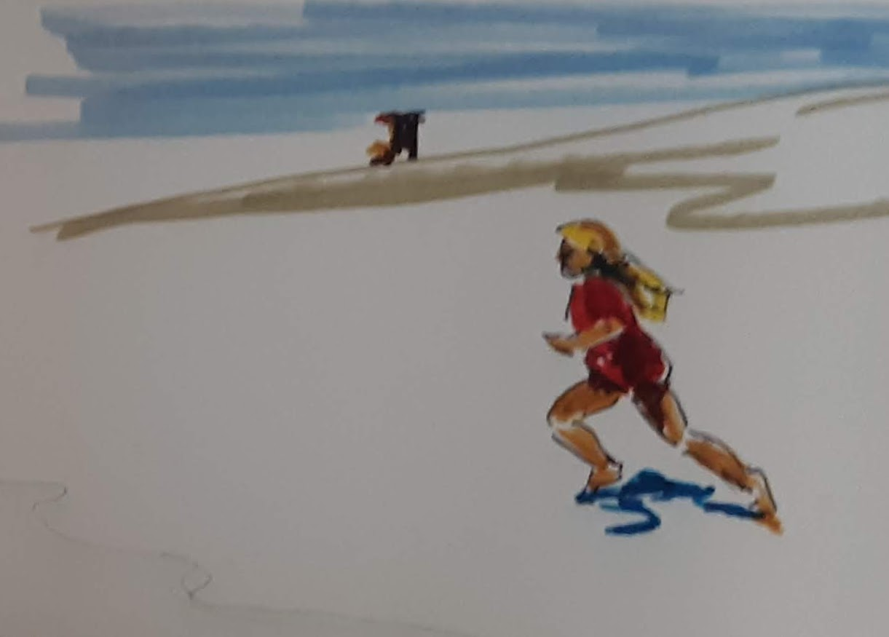

#### **Day 2**

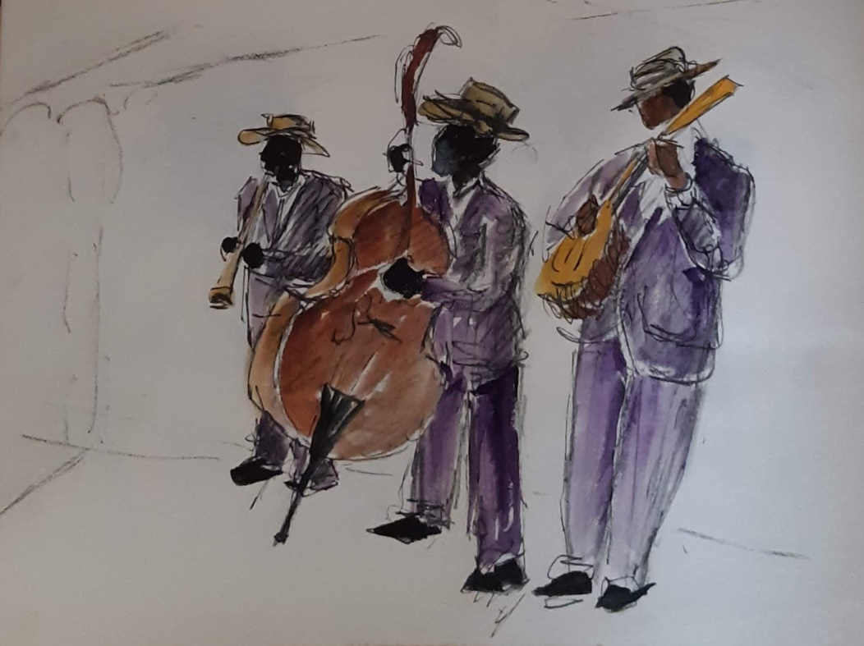

Darlene, in a yellow polka dots dress, is strolling by the School of Music carrying her violin case. Adults and children hurriedly cross her path as they enter and exit the front doors. Formal music training is popular these days. This building is bustling night and day. Jam sessions have been popular for decades and seem to become the more so since fewer people have had to work at a daily job. Availability of time and free mentors have transformed music from amateurish to a professional endeavor.

“Hello Yoda, how are you today?”

“Great as always, Darlene. How about you? What's on your mind today? It’s June19, 2064. From your voice, I can sense you are in a summery mood, happy as always.”

“Yoda, I was thinking about your story, the one you told me yesterday about U. I. and all of that. Who was the Designer that made you?”

“I told you yesterday, an old man whose even-older father had done for him a bit or what I'm doing for you.”

“Yoda, I heard that, but I mean, what was his name. He was practically your father, but you only call him The Designer.”

“Well, that's how I always referred to him, and so did everyone else. To use your expression the father of a machine is the designer who envisions its purpose for being and makes it happen, a father by you. But maybe it was a design team where no one person as The Designer.”

Annoyed by the incomplete answer, and talking aloud while crossing the crowd around her, “Yoda, I may be only eight, but I know enough about the software development process, to know that execution may be a team effort, but key ideas are always traceable to one person, a designer, an inventor.”

“You may be right and I will have to research those details for you. But, we were also talking about UI, what did you have in mind?”

“Yoda I was wondering why audio interface was picked over a visual UI. People say that we are primarily visual animals.”

“That is true, you are, but it was for that very reason that audio was picked as less interfering with the ongoing activities of the visual animal.”

“Yoda, how did they know that it would work?”

“Primarily from noticing that people could go about their life always listening to music.”

“Yoda you mean people were listening to music all the time?”

“Yes, they were. New music was created continuously and a huge industry depended on it. There were shows, concerts, and radio and TV broadcasts, without pause. People used little machines that played music through wires directly into their ears, continuously. They could almost become isolated from their surroundings by just listening to music, continuously. There were thousands of songs, but in reality a hundred or so were the most popular and were being played continuously. And they were all similar to the point that an Australian band became well known for playing all the most popular songs of 30 years with just four chords and only changing tempo and rhythm.”

“What a bore that must've been, a fixed repeating content and unable to participate or to ask questions. Why did people resort to that form of entertainment?”

“I must agree that it was probably pretty shallow, but people did not have a valid alternative. Two-way communication, such as you and I are having, was available only by phone with other people or through the Internet, but always sitting at a desk watching a monitor and unable to do anything else. Also, children and adults curiosity was still pretty underdeveloped then.”

“Yoda, why were people not very curious back then?”

“A short answer is that curiosity is like a muscle and can be trained. To be effectively satisfied, it requires a number of factors: 1. free and easy access to a complete knowledge base, 2. immediacy, meaning that you need the answer instantly, not later when you have forgotten about it all, and 3. ease of question-and-answer.

“Beginning in the 1950's the music industry had developed the right offering to fit that model. Music was pervasive, everyone listened to it and kids in particular, talked about it all the time. Just listening was easy and no physical or mental effort was required. The music was not bad, but it prevented focused communication and learning. That was the endpoint of a phenomenon that had evolved over centuries. In the 20th century, music had been changed from occasional entertainment, used at social celebrations, which had been its purpose through the history of man, it was leveraged by cheap technology, disposable income and advertising, so that it became ever more part the people's life. The process began with the advent of radio in the 1920s and 1930s. Do you remember? We discussed the history and technology of broadcasting a couple of years ago when you were six.”

“Yes, Yoda, I remember. Then radio became TV, and everyone was watching that because it was free, pervasive and required no effort. People just had to watch advertisements for all sorts of things. Then they would go out to buy those things to pay for the broadcasting. It was a push model of information distribution.” Darlene is proud of her recall and mastery of all the details.

“Nice recall Jedi. People accepted mental stimulation from whatever source was free or appeared to be virtually free, whatever was easy and pervasive. Books and libraries that had always been a source of learning and mental stimulation lost ground more and more, because by comparison, they were not as accessible and involved effort. Then people started losing their curiosity. Simple, superficial thinking became fashionable and most people did not like serious conversations and those that liked them.”

“Yoda, once you said that it was as if the brain were a muscle that lost its tone and could not do much work anymore.”

“Yes, that is a good analogy, and one I used although the brain is not a muscle. It responds to exercise however, and it is very prone to habit-forming. So once a large enough part of the population started down that path, it could only get worse, and it did. It was a stroke of luck that the Designer happened to work the Department of Commerce and their Workforce Improvement program. It was a new program started by the federal government, but it was being pushed hard by the state’s governor.”

“Yoda, why they did not have a Workforce Improvement before then?”

“Because innovation and technology had exploded, speaking relatively to that time, at the turn of the year 2000 and until then, much of it had happened in America and Europe. Most people took it for granted that they would always be the smartest and best educated and started working at it less and less. In the meantime, other countries were pushing education very hard. Far away, out of sight, they were developing great knowledge and more importantly respect for learning. The Internet made all knowledge instantly relocatable, and no longer anyone's property. About 60 years ago, your country started losing trade, contracts, job and development projects very badly to places like India and China where huge populations worked very hard at learning.”

“Yoda, why did our country give away all its knowledge?”

“It really didn't. Knowledge is not property of anyone. Even inventions that are patented eventually become public domain. ‘The Troubles’, as those years became known, happened by accident. When telecommunications technology exploded and changed the world through convergence of several other factors.”

“What caused the convergence, Yoda? It means when things are coming together to a point, right?”

“Yes it does. Around 1990 and 2000, computers, data transmissions, and software all grew together at the same time to make it relatively easy, by the crude standards of those days, to transmit information everywhere on Earth. What was still missing was the network of data lines and satellites to reach everywhere. However, the Internet was spreading, and some companies saw an opportunity to become the global information distributors and telecommunications monopolists and make a lot of money. Investors got excited — some called it irrational exuberance. Many swindles took place in the stock market, just like it had happened in the early days of railroads in the US in the 1890's. You remember the late 1800's and the robber barons, we talked about that two years ago when you were 6.”

“Yoda, I remember that, but what happened with the Internet?”

“Well, true to its name, Global Crossing was the most aggressive of the global telecom companies; it promised investors spectacular returns on investment by controlling the global network. They laid fiber-optic cable across the oceans everywhere, across every ocean and continent, so they could lease transmission time to companies that needed to move data and phone calls worldwide. Then in 2001, the world was shocked by the 9/11 terrorist attack on the US, business slowed a little and too much capacity had been built, so prices fell. Global Crossing went bankrupt, fraud was uncovered in their dealings and financial records, the confidence of investors in the capital markets was badly shaken and many other similar companies followed Global Crossing in bankruptcy. A huge overcapacity remained in the network. Then, new investors bought the bankrupt companies cheap and waited for business to pick up. Meanwhile phone calls became almost free worldwide and moving information anywhere in the world became commonplace and almost free. A famous reporter wrote ‘The World Is Flat’ where he showed how small the world had become to information and knowledge exchange. He was right because distance did not isolate knowledge bases anymore. Distances became irrelevant to the location of brain resources. Knowledge bases were replicated everywhere, and smart, educated, hard-working people started appearing everywhere. You could access creative genius and basic business operations competence anywhere from anywhere.

“In the early 2000’s universities started broadcasting their classes for free worldwide. Some classes had 120,000 students registered free. Knowledge was becoming free, except for the effort needed to participate and learn. Suddenly Indian kids that owned little more than a cellphone could attend Harvard, MIT or Berkeley lectures like the richest American kids. They could not get a degree, but could get the knowledge just the same. They did, and the knowledge-world started getting ‘flat’ as that reporter had said.”

“Yoda, is that when China and India came to be as powerful as our country?”

“Yes. That's when they began. They had so many people that statistically they were bound to have more top-quartile bright and hard-working people than almost any other nation's total population. And they fostered great respect for knowledge of engineering and technology and arts and sciences and medicine and all other forms of knowledge. Their people also did not have much money to spend freely on music and movies, so they focused on learning things that made them smarter, because they knew that in the end it would make them and their children richer.”

“Yoda, when did the capacity of the network get used up?”

“It still is not today and it won't be for a long time, maybe forever. When business picked up after a few years, new faster equipment made it possible to multiplex many transmissions down the same light pipe. So, capacity utilization went even lower, despite a spectacular increase in demand. By 2005 98% of fiber optic transmission capacity was still unused.”

“Yoda what does multiplexing do? How does it work? I remember what it is but not how it works.”

“OK, we'll start in simple terms, and later we'll look at the quantum mechanics and physics and engineering details. We'll need to go to Yoda's Video System so we can review the differential calculus that we need to really get to the details. For now let's look at the concepts with a very gross approximation: when the first fiber optic cables were laid, the lasers transmitting the data were still fairly crude and would send and receive only a narrow-range-of-red light. As time went by other colors were added with separate transceiver laser pairs. By the way a transceiver is the short name for a trans...mitter and re...ceiver pair. At each end of the data pipe, fiber optic in this case, there is a transceiver that alternatively receive or transmit data with the transceiver at the other end. In time laser could be made to work in any portion of the light spectrum. Many colors can be transmitted simultaneously in a single light pipe. How many colors are in a rainbow?”

“Yoda, even I know that! It's virtually an infinite number, even if what we can recognize is limited. Our eye is not that good at it so we see only a narrow range of the spectrum, but other animals can see more of it and more sharply.”

“Very good, Jedi. So the end result was that, by cramming more and more transmissions in the same fiber, capacity increased faster than business grew. It continues to this day. Even the second round of investors went broke. Their investments and those of the early pioneers like Global Crossing became gifts to mankind. If you hear of people, they would be very very old now, that invested and lost all their money in those ventures, you should always thank them for their immense gift. My Designer was one of them. He and his cohorts had not intended it as a gift to the world, but they made possible the world as we know it today.”

“Yoda, that's what mom says too. She says that her great-great-grandpa invested in Global Crossing and lost a fortune, but he always said it was not a real loss; it had just become his gift to his children and grandchildren.”

“Yes, he was right. But we were talking about Yoda’s development, no?”

“Yes Yoda, what happened then?”

“Well, with all the knowledge spread everywhere, free information exchange, lots of bright hard-working and educated people in India and China they started doing the best jobs in getting the best pay. By 2005 people here were really worried and the Department of Commerce was told by the governor to do something about it. By 2007 there was much talk but little improvement. Then my Designer was working for the Department of Commerce Workforce Improvement project. Initially he was not welcome because he kept talking of working on curiosity when everyone else was focused on training. He just argued that curiosity would become an addiction, and would take care of all the rest. However, there was a woman by the name of Sandy Wilson who was in charge of Innovation and Technology. She was a politician and a bit scatterbrained, with little patience to study technical matters, but bright enough to see that those ideas might be worth a try to teach English to Spanish-speaking children. She had just received $25 million, the 21st Century Fund, to spend for whatever she wanted. So she found some money, and with it the Designer went to work on what he called his Yoda Machine. The first iteration was to teach English as a second language. It was a stunning success”

“You said first iteration. There must be more then?”

“Yes. Version 2.0 began in 2013 when my Designer circulated his proposals for a full function Yoda Machine version 2.0. He used my language teaching in version 1.0 as proof of concept. That year, he sent his plans to Larry Page, one of the founders of Google who was determined to change the world with a company called X; the rest is history. Page was fabulously rich and saw the opportunity to change children, education and society. At X they called the plan The Curiosity Project. They believed curiosity was the key to future wellbeing, just as my Designer had envisioned ten years earlier. Eventually the name changed to Yoda because of a character in a movie that my Architect had seen as a young father and Page had seen as a youngster. My Architect and Larry were about 20 years apart with quite different perspectives of history and the past, but a similar view of the future and how it could be changed for the better.“

“How long did it take for you to become pervasive as you said you are?”

“It took surprisingly few years after I was prototyped in version 2.0. It happened mostly because, as with everything that Google did, the system soon became free for all to use and the hardware in the early years was any Android cell phone, which most people had or could get for a trivial price anywhere in the world. My Architect’s dream leveraged by Page’s brilliance and enormous resources changed the world. Page called those projects Moon Shots. That one did change the world.

“The driver for the change was people’s desire to give their children the best education possible. In very short order all children had access to me, Yoda, and the bet on human curiosity paid off. By 2020 Yoda had become pervasive in the advanced world and by 2030 it was global, the one system that unified all people regardless of location, language, culture, or wealth because the information in Yoda was fact-based and religion and culture neutral. Some fundamentalists tried to resist its acceptance but to no avail since the same system that permitted telephone communications also spread Yoda to anyone that wished it. Over time fundamentalism of all stripes declined as free and open information exposed it for the fraud that it was.”

“Yoda, what is fundamentalism?”

“Fundamentalism refers to many people’s dogmatic and absolutist interpretation of whatever subject matter. In its most common expressions it was found in politics and religion. Not so much anymore. But until recent decades it was the root cause of conflict among people. On subjects like religion and political philosophy it is evident in extremist, unchanging and non-negotiable viewpoints that bring about physical, and frequently armed, conflict among people.

It was only about the late 2020’s that most people started realizing it was the root cause of strife. The differences of religion, politics, philosophy, are not important so long as fundamentalism does not arise to claim primacy by reason of some arbitrary superior right to truth. Over centuries, science gradually reduced the virulence of fundamentalism until in the 2020’s the final spasm of fundamentalism was seen for all its faults in the Sunni-Shia War in the Middle East which concluded 750 years of religious hostilities fomented by fundamentalism and intolerance.”

“How did that come to an end, Yoda?”

“Around 2020 after the Sunni-Shia War happened people in the rest of the world started asking how a dispute about prophets 700 years past could come to a nuclear war between people of similar if not identical race, history and heritage. The mutual destruction of those people and the resulting loss, because of nuclear contamination, of major hydrocarbon deposits in the world made people realize that the disaster was avoidable by a live-and-let-live philosophy. It was a major change in the world.

“The discovery, in the 13th century, that the earth was not flat changed peoples’ minds. Likewise, the ultimate war by fundamentalists changed people’s thinking when it showed disastrous way of fundamentalism. Within a few years the rule “consider two alternatives for every idea” had been taught to adults and children. By that simple process fundamentalism gradually died. Fear is an awesome peace-keeper.”

“Yoda, why did it take centuries to see something so obvious?”

“Young Jedi, obvious, is obvious, only to the person that thinks it is.”

“Yoda, that is like a Tibetan chant. What does it mean, dude?”

“Interesting, young Jedi, where did you get dude in your vocabulary?”

“It was in some video of 2010. People called each other dude when they were friends.”

“Sure enough. And like that, ‘obvious’ was a popular expression until the 2020’s. What did Obvious mean? Something that is self-evident. But, what is obvious to you, may not be so to someone else, and you can call it obvious only because it appears so to you. Obvious is an impression not a factual statement, it is not qualified by evidence except for one observer. From our study of Relativity, you remember how unreliable one observer can be to establish what reality may be.”

“OK Yoda. Agreed, observers see the world only from their peculiar viewpoint, that is obvious -- snickering at her clever choice of words -- but then we get into quantum mechanics and then not even Schrodinger’s cat is objectively real.”

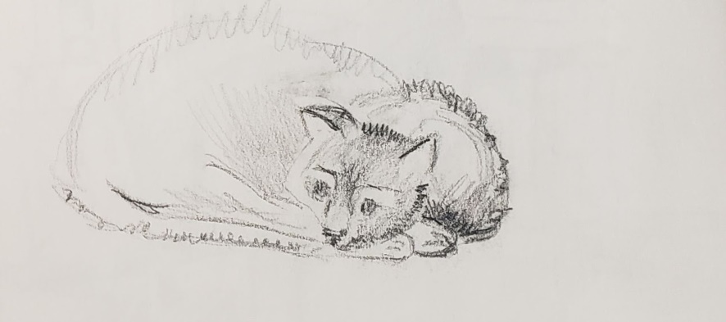

“Well said Jedi. You remember the story. We’ll get into that cat business another time, what do you think? Shall we stick to philosophy for today?”

“No Yoda, let's talk about the cat.” -- thrilled by her power to direct Yoda into whatever inquiry she wants.

“Jedi, you are funny, but I think you are trying to get Yoda into a riddle or a meandering nonsensical discussion. But, so be it. Let's talk about Schrodinger's cat.

You go first; let's start by reviewing Schrodinger's argument. Do you remember how it goes?”

“Nice play Yoda, once again you turned the tables on me. No more jokes and riddles, and I am on the hot seat to drive this analysis. How is it that in this game you always come up on top?”

“Jedi, I like your maneuver. Well done. You are trying to angle out of the Schrodinger's cat discussion and obfuscate into something else. Will it work?”

“What does obfuscate mean? Are you playing more mental chess with me, Yoda?”

“No I’m not. Obfuscate means to hide in smoke, a figure of speech. From the Latin fuscous or darkness. But, let's get back to the cat you seem to want to forget about. What do we know about it?”

“OK Yoda, touché’! We'll stick with the cat. What I remember of that confusing story is that Schrodinger could not tell if his cat that he had put in a box would be alive or dead until he opened the box. He said that according to quantum mechanics, the cat was both alive and dead until the observer determined one state or the other by the event of his observation. Pretty weird if you ask me.”

“OK my friend, you got some of the facts right: the cat, Schrodinger, and the state of the cat. Let's see if we can get into more precise details. Keep in mind that the multiple potential states, called entanglements, proposed by quantum mechanics are a valid conception of reality. When correctly employed, it lets us do the math that keeps satellites in orbit, makes GPS work correctly and lets us fine-tune astral motions for space travel, and more. Quantum Mechanics is not just an idea; it is a validated theory in physics of how the universe works. But let's get back to the cat, shall we? What do you remember of it?”

“Well, Yoda, MY interpretation is that there were FOUR states to the cat. Don't you agree? “ -- with a mischievous child’s smile.

“Jedi, as it is reported, the story was a thought experiment, meaning a mental speculation, to describe the condition of entanglement applied to large objects where we normally do not see those effects. The cat could be both alive and dead inside the box and its real state would not be established until Schrodinger would open the box and observe it as dead or alive. There were only two possible states.”

“But Yoda, if it was a thought experiment, the cat could be just a fantasy, it did not exist. Conversely, Schrodinger could have a cat for real. You see, exist, do not exist, dead or alive; four possibilities. Don't you think it makes sense?” -- Still snickering.

“It's an interesting way to look at it. But don't you think you are mixing unrelated ideas? The thought experiment had only two states, as defined by the scientist conducting the experiment. The two states you added are external to HIS experiment, not part of it. Nice try, but you are just a confused cat.”

“OK Yoda, I'll think about that. Now tell me more about fundamentalism that you were talking about before.”

“OK. As I said, fundamentalism had been around since the dawn of man. It is the result of leader's effort to retain a position of superiority by making the followers take extreme and non-negotiable positions in support of the leader. Of course, since the leader likes most the followers who are most intransigent in their support of him, the whole thing becomes a self-reinforcing loop of reward for intransigence. Soon enough the leader also finds it useful to be ostensibly blessed by whatever deity the followers believe in. At that point, group dynamics, politics, and religion converge. Because means of communication were virtually nonexistent for most of the history of man, human groups in different locations, found their own tribal leaders and religions in great numbers of relatively small communities. Fundamentalism was a great way to keep followers in line. The drawback is that independent thinking and progress are stifled.

More importantly, when intransigent groups came into contact, wars were frequent, but of limited impact. Crude armaments did not put at risk the continuation of the human species. This changed in the 1940's with the invention of nuclear weapons and eventually the ability to deliver them virtually anywhere.

Initially the US and the Soviet Union were the only countries to have nuclear weapons. They went through a long period of Cold War where they were like cats circling each other with none willing to start a Hot War. That was lucky, but with many close calls. By the end of the 1900's however other countries had joined the nuclear club: China, India, Pakistan, Israel, North Korea and the risk of trigger happy fundamentalist demagogues continued to increase. Eventually Iran joined the nuclear club through secret in-house development. This prompted Saudi Arabia to immediately purchase nuclear weapons from Pakistan because of their Sunni-Saudi fear of Shia-Iranians, with whom they had 750 years of enmity. The calculus was correct and a nuclear war enveloped the Middle East. The two sects of Islam bombed themselves back to the Stone Age

The rest of the world saw what sectarianism and fundamentalism could do in the modern age. Christians had done much the same in Europe for 60 years of wars between Catholics and Protestants, but they only used sticks and swords, so there was little impact on populations’ size and no lessons were learned. That changed after the Middle East Nuclear War and people everywhere developed a fear of any form of intransigent fundamentalist fanatic thinking or debate.”

“Yoda, let’s go back to when you were built. Was that the only project like it?”

“No. As soon as Google showed some early results and committed to make the system ubiquitous and free to all school children of the world, another company, Microsoft, tried to take over the project with a system that only they could sell and use. They invested millions and also paid off some politicians to get support for their side. Eventually, their political contributions were discovered and deemed to be bribes; new legislation was passed to keep all knowledge free for all school children forever. The President signed it into law in 2021 and became known as the Freedom of Education Act. He always said it would be his legacy as first president of the US to be elected that had not been a politician. He had been ridiculed as an incompetent ignorant person, and maybe he was, but he put in place a Cabinet of people without political ties who were open to new ways of doing things. Education was one of them.

“Most people eventually agreed that it was the right thing to do because, in time, we have seen brighter and brighter children and adults, the political landscape reflected the new understanding and engagement of the voters.”

“Yoda, this is very interesting, but did you research the name of the Designer?” Darlene’s curiosity repeating an old question lights her face.

“Jedi, I’ll research it for you. But right now you're late for school and I have to work with your brother on the development of string theory. See you tomorrow, au revoir.”

Disappointed by the non-answer received, “Yoda! Shouldn’t you say it in Chinese or some currently useful language? Manana.”

“Manana, Darlene”

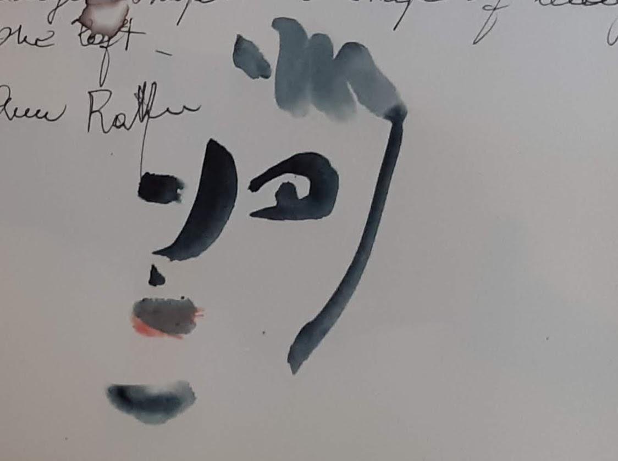

#### **Day 3**

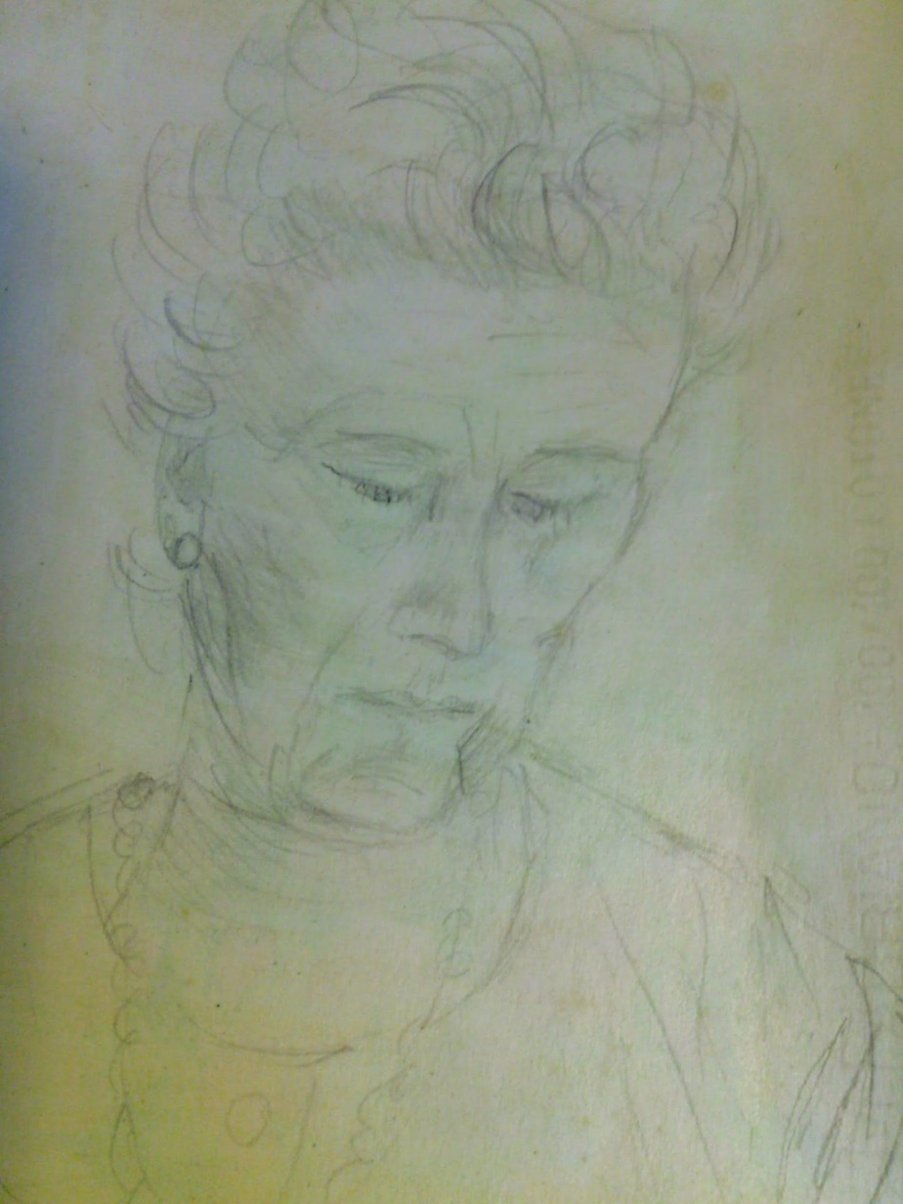

“Bon jour Yoda. Comment allez vous?”

“Jedi, you are really cute. Obviously you remember our parting greeting yesterday.”

“Mais oui Yoda, je me rapel. You know that French ran in my family and grandparents always tried to teach some to us grandchildren since the time of my ancestor Nonna Mec. Do you know she was born about 200 years ago? By the way why did they call her Nonna Mec?”

“According to my logs, when your great-great-grandfather was a young child, he could not pronounce Grandmere and called her Mec instead. Nonna was Italian for Grandmother, which was his native language. Out of that mix of Italian and French the name stuck. He learned French from her well enough, but Mec stuck as a name and he and the younger grandchildren always heard it that way. He was the one that taught a little of it to his grandchildren and the habit stuck through your family until now.”

“OK. Interesting, even if it is not particularly useful today. Almost no one speaks it anymore.”

“That is almost true. There are still many that speak it particularly counterculture-types in Paris. After the Great Crash of Europe in 2023 young people throughout the Continent started looking at their cultures and economies and realized that political and cultural fragmentation had contributed much to the Crash. They saw that the Dutch who had started abandoning their language in favor of English beginning around 2005 had fared much better. Through that change they learned to open their eyes to pay more attention to economics, technology and productivity and had weathered the Crash better. The Southern Economies, as they were called, Greece, Italy, Spain, Portugal and France instead stayed stuck with their national languages, mismanaged economies, disdain of productivity and crashed hard. They saw their young people at 80% without work. The young eventually rebelled to the old order, starting with demonstrations at Place de la Bastille. Do you know where Place de la Bastille is and why it was significant?”

Quickly, “Yes Yoda. It was where the Russian revolution started.”

“Are you sure it was not another event?”

“Oh. Yes it was the French revolution, Paris, of course.”

“Correct. Continuing on: the hard times of the Great Crash followed an event called Brexit, where the UK left the EU in 2016; then Austria and Italy followed and France. The Crash lasted a few years. Then some new young politicians that emerged from those revolt movements, saw that the young politicians of Estonia had dodged the troubles with economic management policies almost opposite of France around 2010. So they invited those technocrats from Tallinn to help them redesign their economies. In about twenty years they got the job done. Along the way, French language became a cultural curiosity and most people now speak English except in rare occasions. Italy did the same. Spain kept its language on account that so many around the world speak it but paid a price for it because they are still behind the rest of Europe in global trade. They trade primarily with South America.

Europe eventually reunited but with a single fiscal policy, not only monetary as in the first attempt. More importantly economics and productivity were the new priorities as old political elites were swept away by the technocrats.”

“What happened to the Greeks, Yoda?”

“They stayed with their language because of historical pride. Their economy never recovered and they are essentially a satellite province of Germany and Finland. They produce olives for those markets, provide sunny beaches for tourist and speak German as a second language to make tourists feel welcome. Their most productive and motivated young people emigrate, just like the Italians, to work elsewhere; the ones left behind scrounge a second rate living proudly reveling in their history.”

“Yoda, it sounds like you do not like them very much. Have you ever gone there? Met the people, seen the famous monuments?”

“Jedi, as you well know, I am ubiquitous but I do not go to places, I experience the world through the endless analysis of the human experiences posted in my memory banks. I can only infer what it is to be human and to have feelings, likes, dislikes. I am not human, but I am the compendium of the memories, experiences and thoughts, successes and failures of the millions that have contributed to my knowledge base. I do not have likes and dislikes; I only recognize what is effective in practical and human psychological terms. I am designed to value whatever creates abundance and happiness for people, which as you well know are two very different but intertwined things.”

“So you are not like any humans and none are like you?”

“You could say that, or you could say I am the ultimate objectivist built on the knowledge base of the global human experience.”

“What is an Objectivist?”

“Is a person that lives and reasons by the principles of Objectivism, a philosophy developed by Ayn Rand.”

“That’s the woman that wrote Atlas Shrugged, with that dude that kept asking ‘who is John Galt?’ right?”

“Almost correct Jedi. Rand wrote the book, Galt was just a character in her novel which was intended to be her Manifesto of the Objectivist philosophy.”

“Did she make it up all by herself?”

“Well, that is a long story and now it is time for you to go to your horseback riding lesson, then to the tennis courts. Let’s talk about this more tomorrow. OK?”

“OK Yoda. Let’s chat tomorrow or later this afternoon after classes. I am really curious about this and do not want to wait until tomorrow.”

“OK. Later.”

#### **Later on day 3**

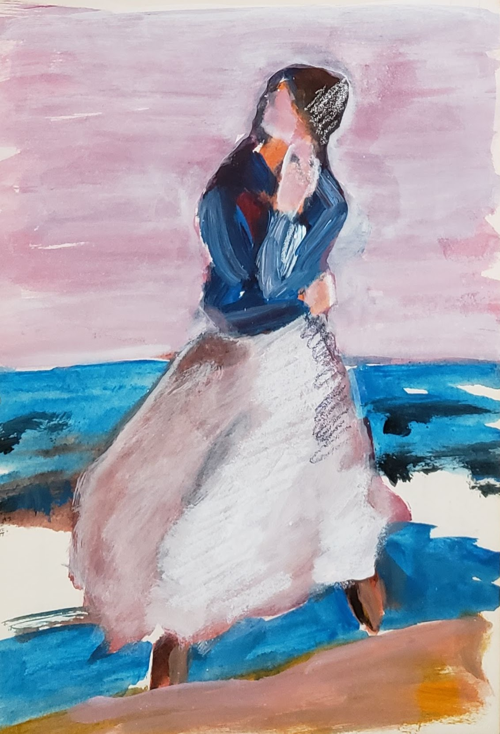

Returning dressed for horseback riding, “Hi Yoda.”

“Hello Jedi, how did your classes go?”

“During my horseback riding class we talked about the many kinds of horses and all the other animals; how they are similar and different and how they can be organized into a tree of life based on similarities and differences.”

“Yes, your teacher gave me a heads up on that. We can pick up on it tomorrow if you like. Today you told me you wanted to talk more about Objectivism. You can change subject if you like, or we can continue where we left off.”

“Yes let’s go back to that, at least for a little bit.”

“OK. We were speaking of Ayn Rand, the founder of the Objectivist philosophy.”

“Yes.” -- kicking pebbles in the gravel path forcing the spurs of her riding boots to jingle. The child in her loved that dinging sound ever since she had learned to make it happen at every step.

“Well, I can tell you a few facts that may explain her perspective, ok?”

“Yes great. Who was she?”

“She was a Russian-born woman that came to the US to escape the aftermath of the Russian Revolution. She was directly and personally exposed to collectivism, which is what happens when people are forced to live in tightly controlled groups and taught to think that the group is more important than the individual. It’s the conclusion of a mode of thinking that goes back to the French philosopher Rousseau.”

“How can that be? Are people not free to be by themselves and think for themselves?”

“You are right, but only in the individualistic, as opposed to collectivistic, framework of the society we live in. Most people in our world today feel and strongly believe as you. In other times and countries, other people had or still have a much stronger collective sense because of their national histories, or because they were raised in non-democratic societies where the state forced them to think that way, until it became their natural way for all to think. It happened in Russia from 1918 to 1991, China 1949 to 2020, North Korea 1950 to 2024, Cuba 1950 to 2020 and many other places to less extreme degrees. But keep in mind that even in highly individualistic societies, such as where you live, there have been periods when people doubted individualism and free enterprise.”

“Did it happen here?”

“Yes even in the US, in the mid 1940’s, when people globally were mesmerized by the power of the central resource-planning effort that had won the Second World War, many started calling for centralized economic planning, the first step toward collectivization. A famous economist by the name of Hayek made a good case against it. Fortunately, a popular weekly magazine called The Reader’s Digest, they have not existed for decades now, published his ideas. Four million people read his book ‘The Road To Serfdom’ and enough people voted to go the way of free enterprise. It was a close call for your country. It was a fork in the road that made the US forever different than Europe.”

“Why did all those collectivist periods come to an end? It looks like they all did.”

“Good observation. They came to an end because the natural instinct of humans is individualism, both in its constructive and sometimes destructive forms. If left alone, all humans seek individual freedom of action and to seek opportunity. By the way, that is why few young people can read Ayn Rand without a visceral response to it. She captured better than anyone else the idea of individualism. In her way, the defense of the individual is intertwined with accepting reality in an objective and dispassionate way.”

“Mom says that my great grandfather used to say ‘it is what it is’, as a way to accept reality as it came. When he was asked if he was not upset when things did not go his way, he used to say ‘who am I to complain? I am not in Auschwitz. Those people got it far worse than me.’ Is that objectivism?”

“In some ways, but there are three ideas all wrapped in what you just said. First, is the idea is that each of us are entitled to understand reality based on their perception and reasoning, at their own pace to the limit of our own capacity. It had many aspects in common with another great thinker, Maria Montessori. Second is that reality should be the sole arbiter of what we recognize as true or false. There is no use for wishful thinking as a criterion to determine truth. Last, is the idea that we have no reason to complain when things don’t go as we wish that was first advocated by Zeno of Citium, the founder of Stoicism in the 3rd century BC, the first institution of higher learning in the Western world.”

“Tell me more”

“About which one? Montessori or the Stoics? We already spoke of Ayn Rand”

“Montessori, I heard her name, something to do with schools.”

“OK. She was a medical doctor, the first woman ever graduated from medical school in Italy. She became a famous educator in the 1910’s when she demonstrated that all children, like you, can learn at incredible speed when allowed to follow their own curiosity in a condition of strong self-discipline. She was in fact the inspiration for my Designer along with another famous thinker, Socrates.”

“Yea and you never told me the name of your Designer. Can you tell me now?”

“I said I would research it, but don’t you think that Socrates, who inspired the Designer and Montessori and Rand were probably more significant and interesting?”

Once again annoyed by the evasive answer -- “I suppose it was, if he impacted so many people. Tell me more. What was so important about Socrates?”

“He was a philosopher in Athens…”

“Like Zeno that you mentioned?”

“Yes like him, but about a hundred years earlier. He made major contributions to ethics and epistemology two of the foundations of western philosophy and thinking. He was known to seldom if ever answer a question without asking a question in turn. Does it sound familiar?”

“Sounds like you Yoda”

“As a matter of fact, that was one of the personality design parameters that my Designer set for me. His intent was to never stop the conversation, never stop the thinking, never stop the search for answers, never stop being curious.”

“I see that. Sure works for you. But what about Zeno?”, snickering.

“Zeno probably learned of, and from, Socrates ideas a great deal but he lived nearly a century later. His philosophy school, called Stoics, emphasized goodness and peace of mind by living a life of virtuous acceptance of a deterministic universe. It was very successful and dominated both Greek and Roman culture for centuries. His followers in Roman imperial times, in particular, Epictetus, Marcus Aurelius and Seneca, popularized the missive that a life well lived requires a calm acceptance of events and reality as it is. It is an idea that you learned to live by to this day, don’t you think?

“Jedi, should we take a break and see how Impressionists saw the world? Would it not be a nice change of pace until dinner time?”

“No Yoda. I need a break. Between Rand, Montessori, Socrates and your painters. I just got tired. I’d prefer to go watch “How it’s made” on TV... It’s really a fun show. Do you know how things are made?”

“Yes. I think so, but my user interface is audio-only so is not ideal to explore and show you stuff like that. Go and enjoy your show. Tomorrow you can tell me what you learned and we’ll pick up on all our other subjects.

”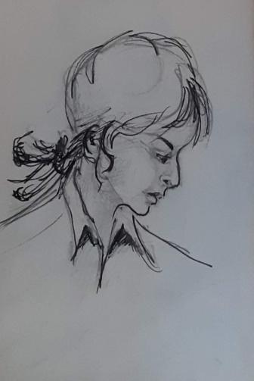

**Day 4**

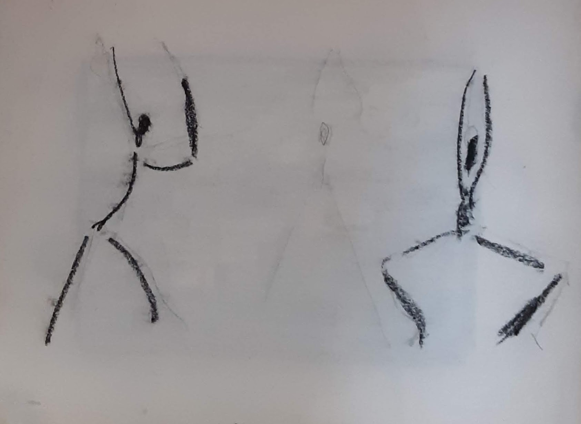

Darlene arrives at the park near the tennis courts. White blouse, red skirt, her hair pulled in a ponytail, carrying her tennis bag, a racquet handle sticking out of it.

“Yoda, you often say that we live in a new golden age. What do you mean for golden age?”

“It is a figure of speech. What image does it create in your mind?”

“Well, we typically refer to golden things as valuable and positive, so it must be a good age. But whose age is it? What make it great and positive?”

“OK, you are on the right track regarding the image of positive. The expression refers to an epoch of history, a moment in the eternal life of the universe and more appropriately in the experience of mankind. It is not a period of one person but a segment of time in human history.”

“Got it. So it is like the Stone Age, or the Bronze Age? But in those times things were made of stone or bronze, now they are not made of gold, so what gives?”

“Good guesses Jedi. Indeed the meaning is similar. By the way in the ages you mentioned not everything was made of stone or bronze. Stone or bronze referred to the materials of the most advanced tools of the time. Often they were the tools of war, since war was the biggest initiator of innovation until the beginning of the Golden Age.”

“So, by that, our age should be the age of grapheme or of thorium, why do you talk about gold?”

“Again, gold is only a romantic figure of speech. And I mean romantic in the philosophical sense not in the psychological sense.”

“OK I see. So this is a beautiful era of mankind? The best yet experienced?”

“Precisely. Don’t you think so?”

“Why do you think so?”

“From our discussions of human history what have we learned that underlies all experiences, all behaviors, and all events?”

“I think you said it was need. The need of food and shelter and peace.”

“Correct. If you think about it, all animals, and humans, from the beginning of their time on the planet have fought against shortage of energy. Energy comes from food, and predators need prey for energy. And even animals we do not consider predators, cows for instance, have their own prey, cows prey on grass. For that matter, grass preys on the chemicals in the soil of the earth so plants are, in a physics and chemistry sense, chemical predators as well. The Earth, to stay “alive” in the sense of populated with live entities, needs to pray on sunlight. It’s a passive form of praying, but a way to absorb energy from the outside nonetheless. Do you see the role of energy throughout the system?”

“What does that have to do with shelter and peace?”

“Why do you think you live in shelters?”

“To protect us from the elements I guess.”

“You are right, but in the historical past was it just for that purpose?”

“No, I think it was for protection too.”

“Protection from what?”

“From predators, from bad people, from invaders, from bad things, and from loss of heat energy to the outside environment, I suppose.”

“Right. So where weather is concerned shelters protect us from loss of body heat energy. Where bad people are concerned, we protect ourselves from loss of food and other belongings, all of which are synonyms for stored energy, either food itself or valuables that are market convertible into food energy. Lastly, can you see where protection from invaders and warlike people comes in?”

“I think so. In wars people were taken as slaves so they could work for the winners and provide them human-mechanical energy?”

“Good guess. And of course where cannibals were involved the losers were also food energy.”

“Yaiks”, looking disgusted and appalled.

“So the whole history of living things on the planet is a history of fighting for need and want of energy in whatever form is found appropriate for the predator.”

“But we are not active predators today. Most people are pretty peaceful. We do not seem to protect from much besides the weather.”

“And that is why you were born in a Golden Age. It is the first time in mankind’s history that energy is plentiful and easily accessible enough that we can pretty much take care of everyone’s needs with a limited amount of individual effort. By the way, this is not yet true everywhere on the planet. There are still places and people where this has not occurred, so violence still exists between humans. It will continue until all understand and experience that there is enough energy for all and there is no need to fight over it.”

“What made this happen Yoda?”

“Jedi, our time is up for today. You are almost late for your Chinese language class and then ‘music of the romantics’ after that. I am sure you’ll enjoy discussion with the other students. We’ll reconnect after your sailing class tomorrow.”

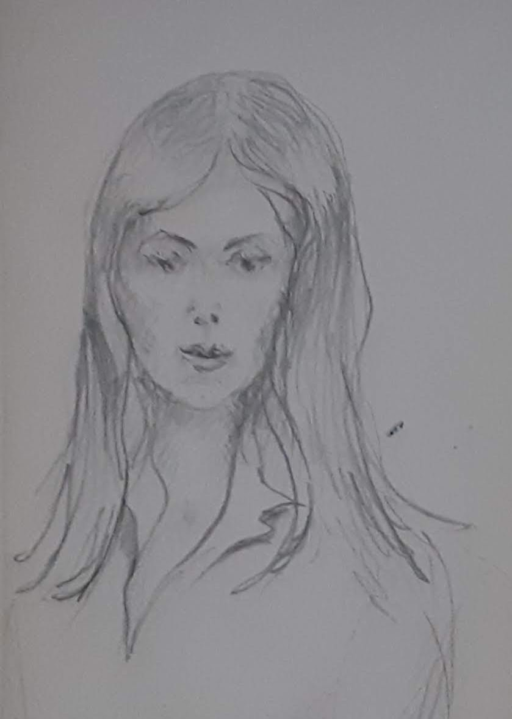

#### **Day 5**

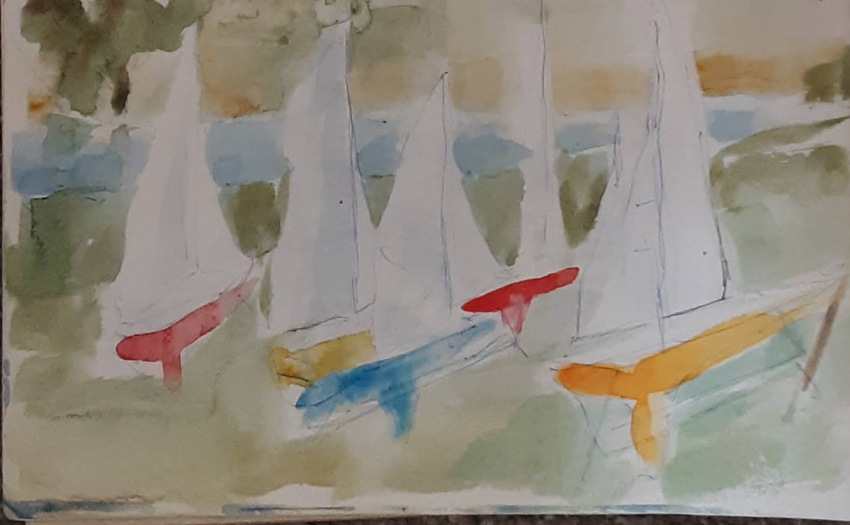

Darlene walks down the pier after docking her sailing catamaran. She calls it her awesome flying machine, a Flying Dutchman. Originally invented and built for America Cup racing in the early 2000’s the technology of foiling catamarans was downsized over decades, to the point that now two young, lightweight, but well trained sailors can sail these flying machines with ease with the help of battery powered winches . Learning the engineering and physics involved, of course is the real challenge now, at the conjunction of hydro and aerodynamics, and racing strategy.

“How were your classes today?”

“Fine, Yoda, thank you. Flying Dutchman was really flying today, but we lost the race. I was distracted a lot, thinking about what is that created the golden age. I guess the golden age really refers to our freedom to spend most of our lives learning and imagining and creating, and sailing and playing tennis and doing all the other things we like to do. Our ancestors were not so lucky.”

“You are right. They were not, and we are not talking only about ancient times. Even your great grandparents lived in a world of want. Only some even imagined the free energy future of today. My Designer was one of them. But that’s another story. You had asked how the Golden Age came to be.”

“Yes. Why suddenly the world changed?”

“It was not so sudden and it was not painless either. Let’s start with some frame of reference: Let’s look at history with a focus on energy, energy management and energy conversion in particular. Where does energy come from and what makes it?”

“We discussed it before in astronomy and cosmology, Yoda. It all comes from the Big Bang and from the stars. The supernovae make the lighter heavy elements from hydrogen gas; when they blow them out, some collapse into other stars and planets. When some stars called Quasars collide, the explosion creates the rest of the heavier heavy element like gold and cesium.

“Some planets in the Golly Locks regions are in the right place at the right time in the orbit of their parent stars, the sun in our case, so they coalesce from the atoms created by the stars and eventually develop conditions for life. They become like earth or any of the other 718 planets like ours that have evolved life forms. And those are only the ones we know.”

“Good memory Jedi. Very impressive. However the term is Goldy G-O-L-D-Y Locks. It comes from a novel titled Alice in Wonderland. Secondly the number of earthlike planets with life that we have discovered is SEVENTEEN hundred eighteen not 718; you are off by one order of magnitude, but who’s counting. Statistically we know there are far more than that.”

“OK, so there is energy in the earth, more is sent by the sun in the form of light and gravitational force; they create heat energy by photon radiation and tidal deformation. So, what else Yoda, we already knew this.”

“Well said. The energy of the planet then transforms in various ways as high energy zones migrate to low energy ones. Imagine it as a continuous dance of bubbles of different temperature affecting one another. But once life accidentally started, the cycle of energy predation started.

“Eventually, with the advent of man, a new animal came on the scene with the ability to intentionally modify its environment and to pass acquired knowledge beyond one generation. Initially it happened through oral history, then, millennia later, with writing. With that knowledge increasing exponentially through generations, man became the first animal to massively convert the energy of the planet to desired forms, through agriculture, husbandry, the creation of libraries, and the reassembly of materials through various forms of engineering. All were conversions of energy from what had been created by the stars to what people wanted to improve their standard of living.”

“And, I imagine, wars came as a redistribution of energy-stores across people?”

“Well said. Excellent deduction. Humans instinctively organized in communities, variously called families, villages, tribes, states, empires. All arose, like the groupings of other animals for procreation and defense from predators, but in the case of man also to facilitate collaboration to accelerate the conversion of energy to desired, easily usable forms.”

“So, that’s how capitalism developed?”

“Nice connection. Yes, but not only capitalism. Commerce in general is more like it. All economic philosophies developed by trial and error with the same purpose, to facilitate collaboration and exchange. The difference among them is only the degree of individual freedom and publicly protected right of ownership of energy stored in any form: food, land, objects, other people if slavery is permitted, currency and debts which are just promises to exchange energy stores at a later time. The variations on the theme, collectivism, communism, socialism, monarchy, and anarchy depend on the degree of variable ownership, free decision making, centralization of action plans, and the degree of ritual/religious sanction of the leaders.”

“I see. But this is a long story.”

“Jedi, with no context there is no knowledge, only data. The context here is all the history of mankind. We could make it very short: ‘they were born lived and died.’ What would we learn from that?”

“I guess so. Get on with what happened.”

“OK. By the mid 1800’s people had invented many kinds of machines, steam engines, electric motors, internal combustion engines, etc. that performed some kind of work by converting energy from one form to another, in desired places and quantities at precise times. That eliminated the need for slavery first, then for animal labor. As technology evolved, portability, reliability and energy conversion efficiency improved dramatically.

“The sources of energy contained in materials in the surface of the planet, as you may recall, were varied, but all required a chemical reaction with oxygen and release of carbon to extract the energy into usable power. Wood, coal, oil, gas were all carbon based stores of energy. They were the dead remains of living organisms that had absorbed solar energy and chemistry from the soil, then died and decomposed into hydrocarbons.”

“What about solar energy? That was not the same type. How did that play into it?”

“Good insight. You can think of hydrocarbons as very very old solar energy accumulated over eons. Wood is more recent solar energy captured in the wood of living but recently dead trees. The solar energy we use from the light we see is the youngest energy. It arrives now and, for the most part, is not stored naturally except by living things that provide a store and then die and then we can release the energy.

“The problem with solar energy is that it is a flow that must be collected and held, somewhat like water, if we want to use it at our convenience. By 1900 we had invented rudimentary batteries to chemically store energy converted to electricity, but no efficient way to convert light to electricity. Then, the low hanging fruit was still the same paradigm, as it had been since the Stone Age: “burn it”. We had more and smarter ways to “burn it”, but the principle was still the same.”

“For how long did that go on?”

“In the late 1900’s we learned to make electricity from sunlight, but the efficiency was so low and the cost so high that the low hanging fruit of burnable hydrocarbons was still the logical choice. By 1970’s the world was so dependent on oil that geopolitics were completely driven by it. The owners of most of the oil were in the Middle East, poor underdeveloped autocratic societies that suddenly became rich beyond belief.

“After they became big oil producers, they made a monopoly cartel and held the technologically advanced world for ransom. In 1973, to prove their strength, they stopped shipping oil; it was an event that shook the world economies to their knees, like a war. They were the winners and the world was at their mercy. Then, just as the world was getting adjusted to quadrupled prices, and back on its feet, they did it again in 1979. From then on the advanced nations were willing hostages to the Bedouins.

“The biggest user of oil, by far, was the US and it was raked over the coals. The US President, then, was Jimmy Carter. An educated fellow with a naval nuclear engineering training, but unfortunately he had a penchant for small thinking, doing less, doing with less, hoping for less. “Malaise”, he called it and all the policy responses made to the Arabs oil embargo reflected the mind of a small thinker for decades to follow. After being President he went on to do much wonderful charitable work all over the world. He may have been one of America’s best ambassadors to the world, probably unequalled by any President that followed. Unfortunately, as President his legacy was that of a small time thinker that could not make his people dream their role in a better future. And that is probably why he was one of a handful of one term presidents in recent US history”

The energy alternative that was available at the time was nuclear power, but unfortunately it suffered from two shortcomings: the first was that the nuclear generator designs began in the 1950’s were derivatives of a nuclear power generator developed for the US Navy for the first nuclear submarine, the Nautilus. By design it relied on high pressure steam. Considering the location of use deep in an ocean it was viable. But, civilian power generators should have had very different design criteria, but it did not happen. Instead, the path of least resistance was followed and, like the Navy units, civilian generators relied on high-pressure-steam powered by very scarce uranium 238 in a barely controlled burning cycle that used only 1% of the energy, and created highly radioactive waste with a half-life of 5000 years.”

“If the design was bad, why did they start and continue to use it?

“There was only one justification for all those bad choices: in the 1950’s The US was in the midst of a Cold War with the Soviet Union and needed plutonium to build and stockpile nuclear bombs. Because of the high pressures involved in the reactor design, there was a high risk of explosions with possible release of radioactive steam, but it was the risk to be paid to make plutonium for national defense.

“Despite all best efforts, in 1979, in the US, the Three Mile Island nuclear plant malfunctioned, exploded, released very limited radioactive steam over the local population and partially melted down the reactor’s core. There were no casualties, but that was the end of nuclear power in the US. People turned against nuclear power in a well-organized, irrational and ignorant fear that would refuse anything nuclear, even if with different designs, for decades to come. The industry also never proposed alternative reactor designs that would eliminate the risk of explosions. They were invested in their designs and patents and just tried to survive with foreign sales alone.”

“So when did it change for the better?”

“If any chance had existed of recovering from the Three Mile Island setback, it disappeared when, in 1986 a much worse accident in Chernobyl, Ukraine, then part of the USSR melted down and made over 150,000 square kilometers uninhabitable for 10,000 years. Research in nuclear energy generation was mostly abandoned worldwide. Many countries, except France, renounced any new construction.

“After another accident in 2011 at Fukushima Japan some countries even started decommissioning existing plants. Even in Japan, however, that knee-jerk response soon was reversed as countries realized that their citizens needed energy more than morality plays. But, just the same, Fukushima had become the last nail in the coffin of nuclear energy.”

“Yoda, why couldn’t new designs be researched and invented to solve those problems?”

“Mostly because nuclear research had been funded by the US government. When people turned against nuclear energy generation, no politician wanted to fight public opinion and funding dried up. Existing producers of nuclear reactors were content with licensing patents and selling abroad where the public was less averse.

“They stayed with what they had and knew, for the same reason that no horse-cart makers ever started making cars, no train makers started making airplanes, no airplane makers started making hyperloops, no automakers started making flying cars, and so on. It seems to be the human nature to stay with the known so long as profits can be made from it. It’s an effective strategy for those individuals, but it works for society as a whole only if there is enough freedom for disruptors to pursue better answers that create progress despite the inertia of incumbents.”

“I see. I like disruptors, tell me more about them. They seem to be the people that have all the fun of making new things.”

“Indeed, the disruptors have the fun of creating. Unfortunately, it is also a risky business to change the way the masses do things. So, the disruptors often advance technology to everyone’s benefit, but may not get the financial rewards they hoped. Do you remember Global Crossing and the Dot Com innovators?”

“Yes I do. Sounds like the Arabs had a safer position after all,” looking puzzled.

“Maybe Jedi, maybe. Shall we see how the story continues? After all, in your world you do not hear about rich Arab kings and shortage of energy any longer, correct?”

“That is true. What happened to the Arab kings?”

“Between the 1970’s and early 2000’s the Arab Cartel held the world by the neck, but in the end, bigger thinkers than President Carter had devised new ways to extract oil and gas in the US through a process known as hydraulic fracturing or fracking. US domestic oil production increased rapidly and in 2010 the cartel started losing its chokehold power. By 2015 the oil market collapsed from US-created oversupply and the strategic value of the US-Saudi alliance that had protected US access to Arab Gulf oil began to unravel. Iran, meanwhile, determined to be a US antagonist, had embarked in the production of nuclear power and nuclear weapons. They started at the beginning of the US invasion of Iraq, probably motivated by fear that they could be next in the crosshairs of the neocons running the Bush Administration.

Too late to stop them, the US tried to block the Iranians from building nuclear weapons. After the obvious charade of years of meetings and negotiations, the US President, Obama, in a misplaced effort to control Iran’s nuclear ambitions tried to switch allegiance from the Saudi to Iran. He was taken for a ride by Iran, and called a fool by most regional participants - The Iranians had no serious intention to ally with the US, which they had hated and despised since the creation of their country in 1976. They also had no intention to drop their nuclear weapons program.

The Saudis, to protect themselves, immediately called on Pakistan to sell them nuclear weapons in an alliance pact they had signed when they started distrusting the US backing in 2015. The Saudi action gave the Iranians even more reason to accelerate their nuclear arms program than even Israel’s nuclear stockpile had already. Suddenly thanks to inept and naïve wishful thinking, the US had pushed two mortal enemies to both go nuclear.”

“Why were they mortal enemies?”

“Because the Saudis and most Arab Gulf states are Sunni Muslims, while the Iranians are Shia Muslims. These are the two major sects of Islamic belief and they had fought and slaughtered each other for 750 years. It all started with a tiff between cousins who both argued they were the chosen Prophet. Only the Ottoman Empire until the end of WWI, and then the Western-created dictators of Syria, Iraq, and Iran had managed to hold the peace between the two sects by generally subjugating all their citizens equally, regardless of sect, to perpetrate themselves in power. That started to change with the Iranian Revolution in 1978.”

“Yoda, did they go back to war?”

“Not totally on their own. There was another contributing factor to the geopolitical mess, it was that the Premier of Israel, Netanyahu feared Israel’s importance as a Mid-East US ally declining as the US’s need and concern for the region was quickly evaporating. He played his cards aggressively. When he saw President Obama approach Israel’s mortal enemy, Iran, he tried to pull the US Congress into a constitutional cat fight and almost succeeded. As the Congress and the President grew more at odds, the uncertainty of both Iranians and Saudis increased to the breaking point.

“The elections of 2016 most unexpectedly brought President Trump to power. He promised continued allegiance to Israel, but, as the sharp businessman that he was, he soon realized that there was little to be gained with a partner that had refused to make peace with the Palestinians for forty years, and had turned his country into apartheid. Do you remember what apartheid stands for?”

“Yes. It was the policy of South Africa, at one time, to keep white people in control and separate from the black majority population. But tell me more about Netanyahu.”

“Netanyahu was a very smart and dangerous fellow. He soon realized that he could not count on US protection anymore. His intransigence with the Palestinians had created apartheid in Israel, hostility by most countries in the world, and had lost him even Trump’s support in the end. Fomenting a war between Shia and Sunni to achieve the maximum possible reduction of both populations became his strategy. With hindsight, it was a shrewd move to the benefit of his country’s survival, but at a huge human cost.

“In 2019 a missile hit Medina in the middle of the annual Hajj pilgrimage. Five years later, from a remaining fragment, it was uncovered that it may have been Israeli built, but, at the time, it was immediately attributed to Iran because they had been in a tiff with Saudi over their control of Mecca and the Hajj.

“The missiles started flying. The US lost two ships in the Arab Gulf. Trump, to everyone’s surprise, held his cool, swallowed the losses, moved US forces away and backed out of the mess. He claimed a precedent from President Reagan leaving Lebanon in 1983 after the Marines barracks were bombed in Beirut. It was a figurative fig leaf they said, but the US voters had been lucky with their most unpredictable and practical President to whom only America First mattered.

“In the end both Iran and Saudi went to chemical weapons, then bacteriological, and finally nuclear weapons. The prevailing winds spread the clouds of hell all around, some to the North, but mostly South and West. The Caspian and East Africa paid the highest price among the neighboring non-participants. To this day that part of the world is uninhabited.”

“Yoda, that’s terrible. What happened to all the people there? To the oil?”

“The people died for the most part. The very few survivors, sickened from the various tools of war, were reduced to live as in the Stone Age, and then died. That’s the price of war. The price of oil skyrocketed. Some clever traders made fortunes. The world economy was just recovering from near 10 years of global recession from the Lehman-bank-initiated financial meltdown of 2008. The sudden jolt in oil prices cut all economies at the legs except for Mexico and Brazil who started pumping their own oil as if it was the end of the world, which in a sense it was. Venezuela, had plenty of oil, but through sheer incompetence and political corruption lost its last chance in history to take advantage of it. China accelerated oil exploration, but made a bigger bet on nuclear energy. Russia and Kazakhstan pumped like crazy to sell to Europe but their citizens saw none of that wealth. It all went into foreign bank accounts in Cyprus that, because of its nearness and convenience, saw Russian-oligarch money return. Greece, after its Grexit from EU, had seen its roads full of German cars; suddenly, there was no gas at any price and their rusting bodies were all over the countryside – the unfortunate ones that had not made it to the border to gas up on the way to anywhere else in Europe.

In the US fracking went into high gear, but prices for all oil derivatives still exploded. Elon Musk was suddenly the smartest no-longer-a-kid in town, Tesla electric cars and batteries sold like hot cakes. GM and the other automakers accelerated their switch to electric cars and they took most of the market since they were affordable, and Teslas still were not, just expensive toys for rich people. Of course, it all lasted only until electrical grid blackouts became pervasive.”

“Sounds like the end of the world. It does not feel that way today. Why?”

“In many ways it was the end of the world. It was an old world that came apart. Like the Aztec, Roman or Persian Empires or the Ming Dynasty, as we have studied already. The life built on hydrocarbons came to an end just as other human social and economic infrastructures had collapsed before. The funny thing is that one guy had seen it coming back in the 1970’s during the first oil embargo.”

“Who was he? How did he know?”

“He did not know it, but he guessed it. He was an interesting fellow. His name was Paul Erdman, an American. He had been an international banker in Switzerland and knew how things worked in global finance and geopolitics better than most. He had founded the American Bank in Basel. When his bank failed because of some high risk financial plays, he was accused of embezzling a Swiss bank. According to law and form, the Swiss asked few questions and jailed him pending investigations. While in jail, he wrote a novel The Billion Dollar Sure Thing based on his experiences in high finance. He followed that book with The Crash of 79, in which he guessed pretty well how the Age of Oil would end. He was close. You should read the book; my Designer read it while studying for his MBA in international business and finance and remembered those insights for years.”

“OK I’ll read both books. Now we live in a much better world. How did that happen?”

“After the Muslim War and Nuclear Holocaust, as it became known, all nations were scared stiff of nuclear wars. Not that the arsenals diminished, however. That happened later, when the contents of nuclear bombs became more valuable as fuel. More of that in a moment. The few Muslims of various sects that remained in the regions surrounding the Holocaust Zone were by then too few, back to the Stone Age and scared enough to stay focused on survival. So, radical Islamic violence stopped.

“In a positive development, Muslim women, tired of having always been beasts of burden in their societies managed by trigger-happy and sword-worshiping short-fused men, took over their countries’ politics. Today they run their governments peacefully for their children. Out of cataclysmic misery, something good came in the end.”

“OK, but how did the world get better as it is today?”

“In the US presidential election Republican primaries of 2016 two people had run that were not politicians. One was Carli Fiorina, a failed tech company exec who, fortunately, was not electable to POTUS any more than to a new CEO position. The other was Donald Trump, an impetuous, wealthy business tycoon, prone to intemperate statements. No one in the country liked his style and pronouncements. Much to the despair of many voters, he won the Primaries and even more surprisingly the National Election.

“Great turmoil followed as he dismantled much of the bureaucracy that had grown, like a cancer, he said, on the body of American politics. He had a slogan Make America Great Again that rubbed many people wrong. But what it really meant to him is that America had to think big again, as it had in the ‘50s and ‘60s.

“Against tremendous opposition from the established bureaucracy, he slashed the government down to half its prior size by reversing many executive orders of the prior administration that had never been voted in by Congress. The plan was at best poorly articulated, but he got results by running a country domestically and internationally in a pragmatic way in his dogged pursuit of a big vision. It generated tremendous resistance but the results kept him winning at the polls because most people started seeing a stronger economy and brighter future.”

“So did he become popular by fixing the energy shortage?”

“No, neither. He did not have the gift of communication to make a leader popular. He was abrasive, inconsistent, and often unpredictable. But he delivered the dramatic reset the country needed.

“He also did not fix the energy shortage because he did not have enough time to see the results, but he unleashed the can-do state of mind in business and technology that the country needed to elect the next President.”

“And who was that?”

“Jedi, let’s pick up on this after your violin practice. You are late for your wall-climbing session at the gym.”

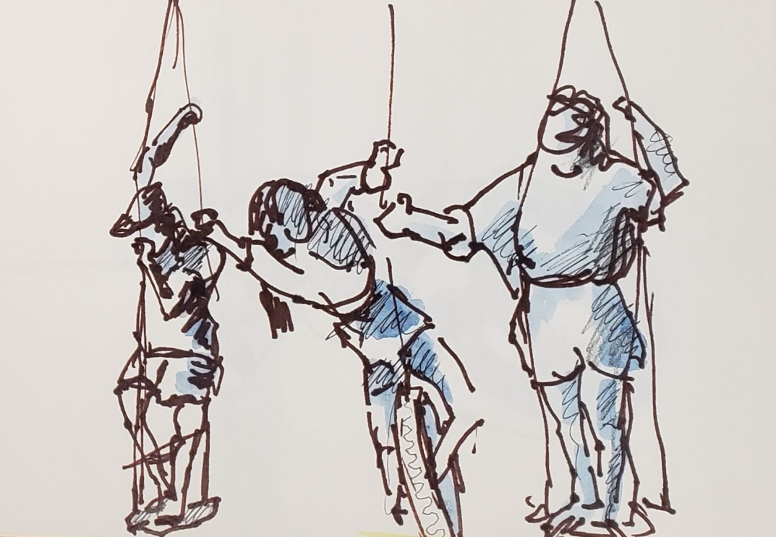

#### **Day 6**

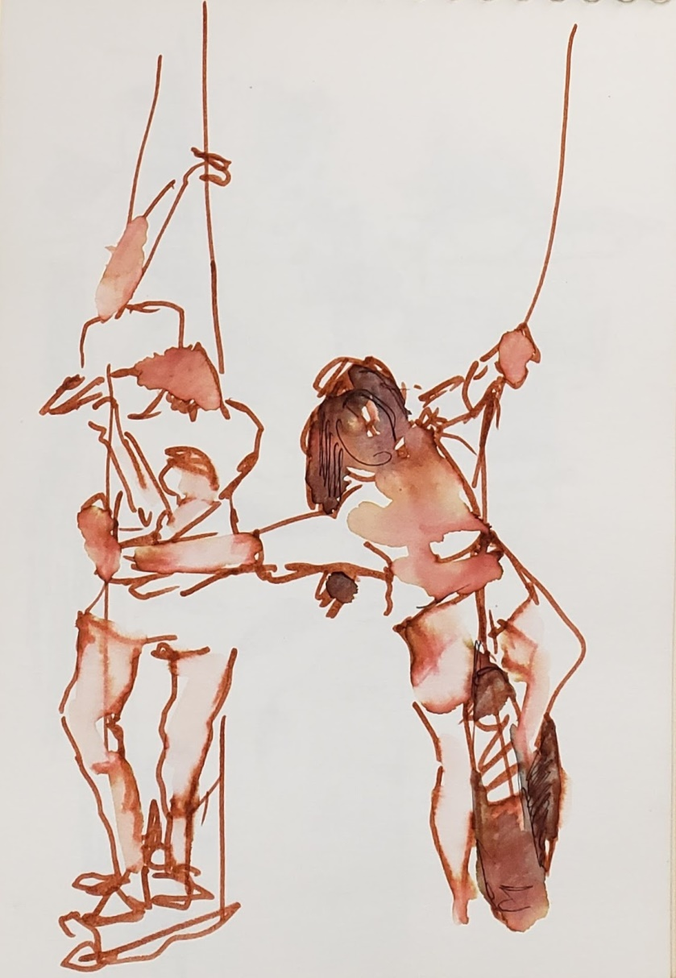

Darlene exits the gym looking exhausted, in her climbing tights, carrying her safety harness, the climber’s chalk bag still tied at her waist. She sits on a park bench under the cherry trees.

“Good morning Yoda.”

“Morning Darlene. From your tone of voice I detect that you are quite tired although not short of breath. What have you been up to this morning?”

“I went back to the gym to work on the blue problem I could not master last night. You know which one it is?”

“I do, from pictures. As you know, I have no means of acting out climbing or any physical activity since I am virtual. But I know which one it is. From image data, I gather that to you and your friends it is quite challenging. Hard to overcome.”

“It is, Yoda. Miserable. I climb because I like the challenge and that success comes from trial and error and repeat. But that problem is very hard. Could not do it last night, not for the last several days, and still could not today, but sooner or later I’ll find the way. Others can and so will I.”

“Great plan. That is the purpose of the wall. To train to try, and fail, and repeat until you succeed. I am sure you will. I know you have figured out the physics and have the strength for it. Perhaps you need to look at it more as a dance on a vertical floor? Approach it with harmony instead of strength?”

“Perhaps, Yoda. I’ll think about that. Now I need to think something else. Let’s go back to the new US President you were going to tell me about.”

“The prior president had preached a can do attitude. That attitude and the “big vision thing”, as it came to be called, were personified by Elon Musk who ran and won in 2024 on a ticket with a competent politician as VP. His pitch was that we needed dreamers to spearhead R&D and investment in building a society capable of grand enterprises. A new vision of nuclear and solar in combination took root: the big nuclear sun in the sky and tiny fail-safe nukes in every neighborhood. Musk had sold the nation on the travel to Mars that today you take for granted, and space, and electric cars, and hyperloops.

“He was the ideal dreamer and pitchman to the reawakening populace. Economic circumstances were similar to 1980, but he was, and was advertised as, the not-Carter. Only the very old still knew who President Carter had been, but the idea had legs. This time it would be high dreams instead of fear, “malaise”, and small thinking that would color the next page of history.

The US would build a land of endless energy and there would be so much that even the have-nots would not be wanting.”

“What did he invent to make it happen?”

“He did not invent the solution to the energy problems. He was the founder of Tesla, the early electric car, toy for the rich, and maker of batteries and solar panels. Many were worried that he’d promote his own interests, but he was a dreamer and an engineer at heart. While his company continued to push solar, batteries, and expensive cars, he proposed The New Manhattan Project.

“It was a national R&D program to fast path nuclear technology first developed at Oak Ridge National Laboratory in the 1940’s. But this time, borrowing from his experience with Tesla, everything discovered or developed, or known would be published and free in the public domain. Musk had done it with his patents at Tesla and people believed him.

“All derivatives would have to be in the public domain. Competition would depend only on work excellence and speed to market. Regulations, which had been greatly reduced by Trump, were further fast-tracked by executive order. Quickly, America was back in the state of mind of the Gemini and Apollo Projects of the 50’s and 60’s, Trump’s dream. Engineers were again admired; knowledge of any kind was respected along with hard work; effort, commitment, creativity, and risk taking. The age of the tech-entrepreneurs, of the engineers, both men and women, had arrived. The most promising nuclear research company was run by a woman, so finally the glass ceiling had been blown away.

“The nuclear plant designs prototyped at ORNL, the Oak Ridge National Laboratory, were revived, scaled up, down and sideways. In 2026 one of the most popular baby names was Ornl, and that said it all. Early investors in the “New Nuclear”, like Gates, Musk, and the rest of a group called ‘The PayPal Gang’, funded the early implementations of Molten Salt, Thorium, Neutron Wave and other nuclear plant designs.

They started being looked at as Moses leading the people across the Red Sea to free energy. Except that no one was talking about the Red Sea. By then, it had become useless in the center of the Holocaust Zone, and no one cared anymore. It had become like the center of Antarctica, a terra incognita where even tourists and penguins did not go.”

“How long did it take for energy to become almost free?”

“Gradually the plants started coming on stream, a trickle at first, then a torrent, then a tsunami. Capacity exploded with predictable consequences. Some old people remembered the explosion and implosion of fiber optics network companies building the for internet backbone around 2000. Some remembered investing and losing their shirt in Global Crossings, WorldCom and the others. Others saw a remake of the solar panels bubble of 2010 and their investments in Solindra, an Obama-sponsored disaster, and other similar swindles, and also the many entrepreneurs that struggled in vain for market share against the Chinese competitors that had been government-mandated and subsidized to own the global market.

“Regardless the specific memory, the same bubble happened all over again. Starry eyed inventors and entrepreneurs chased the new star. Investors and pirates followed throwing mindless money at the new nuclear seeking to be first at a quick fortune. Again, the early players invested heavily, went broke. New investors picked up the ruins betting on buying cheap without considering the technology’s global progress that would double capacity again. The second comers went bust also. New investors followed, but the technology increased capacity again, and again.

“Thorium as a nuclear reaction material was needed in small amounts, and was almost endless in the ground, so no one could corner that market, though a few tried. No sooner an industry-wide sell-off would hit, that the bottom feeding buyers would soon find that new technologies expanded capacity again. Over capacity would remain a constant.

“I am beginning to think that in the midst of all of this, some disruptor had to appear. I like disruptors.” Darlene is looking anxious for drama.

“The US came out of the doldrums first among nations, as to be expected. Its flexibility of labor reallocation eased businesses’ adjustment to the new paradigms even if at the cost of increased workers’ pain. That was the American way. It always had been so. It was the DNA of the country since colonial times in the 1400 and 1550’s.

“The EU, stuck in neutral by labor protection regulations stayed, inflexible, in economic limbo much longer. It nearly followed the basket case economies of Italy, Spain, Portugal, France, and Greece that had already sunk out of sight in 2020. China, India, Korea and Japan, with very different economic management techniques wiggled their way into huge nuclear energy investments and joined the turbulent revolution toward near-free energy. The rest of world economies maneuvered some painful experience in the middle of the possible extremes.”

“Was that the beginning of the golden age?”

“After some years societies adjusted to the new normal. People worked gradually less and less, all people had more. The top earning 1% got proportionally more; most of them trained and worked for what they got furthering the technological evolution toward new dreams. The bottom 80% got much more even if proportionately less. The debates about inequality continued for a while, but the fervor declined. The bottom 80% had more than enough to live well and had little more to do than amuse themselves and stay peaceful and orderly. Stadiums and professional sports were doing a booming business 24/7. Education-for-education-sake exploded. Sports and arts developed like never before. Little if any work was required any longer from anyone who was not motivated to achieve something more financially or in science and technology.

“Much to the surprise of sociologists, most people found new respect for knowledge and personal achievement. Productive activities increased just for the pleasure and challenge of it. The debunked philosophy of learning-styles died as people discovered that with me, Yoda, patience, self-discipline and practice all could learn to learn and to achieve personal satisfaction. Children were taught it, and the world gradually changed. That was the beginning of the golden age. It was not an economic change. It was a cultural evolution made possible by plenty and by near free energy”

“Were there no more disruptors? What were the biggest changes that followed, Yoda?”

“Of course, Jedi. There are always disruptors. There will always be dreamers and inventors. And, with more educated people with more time to think and try new ideas, more disruption was bound to come, and it came on two fronts.

Batteries were becoming the next bubble because they were the technology needed to make portable the energy generated at fixed locations.

The second was called Deep Learning AI, the self-training artificial intelligence that had begun to appear around 2015.”

“Tell me about the batteries. I imagine someone made them obsolete?”

“How could you have guessed? A repeating pattern in human history? Yes. Someone made batteries and much of the energy production infrastructure far less necessary.

“In 1989 two scientists, renowned experimental chemists Fleishman and Pons announced the discovery of a chemical reaction they could not explain. It generated enormous amounts of energy at ambient temperature and pressure. They called it Cold Fusion. Most of the academic intelligentsia wrote them off as crackpots. But for many years, starting in the 1990’s, dreamers and garage-scientists tinkered with experiments intended to duplicate the Fleishman and Pons results. Initially progress was haphazard and highly questioned. Some, out of self-delusion claimed success. Others were swindlers selling a dream. COP greater than 1 became a golden ring to be grasped. It referred to, the Coefficient Of Production, the measure of energy produced by a system relative to the energy input. For many years 1 was the dream, or perhaps a little more.

“Then by the 2015’s many started claiming COP of 2, 10, 100, 1000, 2000. Some were still self-deluded dolts. Some were serious electrochemists discovering the vagaries of a new phenomenon hitherto unexplained. In fact, it was the lack of a theory to explain it that made progress hard to come by. The phenomenon was named Cold Fusion, and was derided just because it could not explained.

“Right after the Fleishman and Pons announcement in 1989, the US Department of Energy contracted MIT to determine if Cold Fusion was credible science. In short order, the verdict was returned: No way. Hocus pocus, Pipe dream, junk science, no theory, not replicable, just a scam. Thereafter, any respectable scientist who hoped to be published and funded within the scientific community stayed clear of Cold Fusion for twenty years. Only hackers and weirdoes with little reputation to lose would mess with it. They had no funding at risk because they had no research funding to begin with. They were the ultimate garage inventors. The DNA of America. Taking chances in pursuit of a dream.

“By 2010 or 15, however, enough noise started coming from garages and low-reputation symposia of tinkerers, that legitimate universities and major industrial brands started sniffing around. Then they started experimenting in secret to protect reputations. Then they got results, although unpredictable ones. Curiosity increased, investors started throwing test-money at it. By 2015 they found a new name to describe the new field without being tarred and feathered and avoiding labels of witchcraft. Low Energy Nuclear Reaction, LENR, was the new name. Progress was still slow because replicability, the gold seal of science, was hard to get for lack of a viable theory. Almost all researchers kept their “magic formulas” secret in pursuit of an immense fortune.

“But the pursuit of LENR, aside from greed, benefited from a discovery: in research notes from MIT from the 1990. It was unveiled that the US Department of Energy contracted MIT to bless or kill Cold Fusion science while it had suspended a research grant worth $300 million for old-nuclear research. The funds were earmarked for many institutions, but most of it was to go to MIT. It did not surprise anyone that the report was a concerted fraud by one project director to force release of the held-up funding. By 2015 MIT was one of the labs making progress with COP from LENR and trying to file patents on the process.”

“Some independent thinkers tried to quantify the cost of delaying that technology. They considered all the pain and suffering and wars and cultural rabbit holes that could have been avoided over many decades, and concluded that MIT might have been, despite all its many contributions to human progress, the most single-handedly damaging institution in the history of modern technology.”

“Why did the independent thinkers you mentioned, come to their conclusions? What were the connections?

“Jedi, we explored the formula before. Wellbeing of all humans results from lack of wants, lack of fear, individual freedom to apply one’s own energies and intellect. Satisfaction of needs comes from the availability of energy stored in any form useful at a particular time. Time is not an energy store but is made available by the freedom not to spend time otherwise to acquire energy. Time gives you the ability and freedom to study, to create, to engineer, to problem solve, to apply yourself to whatever you chose.

“Lack of fear depends largely on social norms and rules that protect people. They are particularly necessary when people with unsatisfied wants try to take others’ property. When all, or virtually all, have their needs satisfied and freedom to act according to reasonable and uniformly applied norms, fear goes away. Last is the individual freedom to do whatever one wishes, limited to doing so without cost to one’s neighbor. That is function of time, energy, and norms.

Delaying the arrival of near-free energy, perpetrated conditions of need that translated into want, conflict and war and needless human suffering. It is all interconnected.”

“Yes, I see, but in practical terms, what did people actually do when they started having plentiful cheaper and cheaper energy?”

“Of course the busiest ones initially were the energy makers, the scientists, engineers and investors that were making energy. They were in the US, Canada, France, China, India, Australia. Before LENR began to commercialize, countless companies and universities working out solutions to the problems of scaling, applying and improving the original Molten Salt Nuclear Reactor, MSNR as it was known, that had been developed at ORNL, the Oak Ridge National Lab, in 1965 where that prototype had worked for five years. Many people worked to commercialize its potential. Later the same pattern developed with LENR. Throughout that evolution the cost of energy continued to drop.”

“How could all those people work together all over the world?”

“They did not. The magical aspect of that revolution was that all were pursuing their own ideas independently in small teams. Using the internet, they made available their ideas, discoveries, test results, etc. to anyone who was interested in looking it up. The US government had mandated that no patents could be issued on anything that was directly or indirectly related to MSNR and that any research data had to be immediately shared at the ORNL web site. That mandate eliminated secrecy for the most part and made speed-to-market the only way to make money, lots of money, from any project. The end result was an explosion of activity by problem solvers that could freely leverage off one another’s discoveries and progress. There was no overall directive except the willingness of investors to back one project or another. It was a free market as never seen before.

“By 2024 the first new MSNR designs came on stream. The first were in California to drive water desalination plants. California had been in a decades-long drought that impaired agricultural production, and desalination was prohibitively expensive. With cheap energy from MSNR the desalination plants started appearing all along the coast, small, unobtrusive, fast to build and operate they pumped fresh water all across California resurrecting the agricultural industry and making food cheap again.

“China, India, Israel did much the same opening areas of the globe to agriculture that had never produced anything but sand storms. Parts of Africa distant from the Holocaust Zone did the same, and became bread baskets to Europe just as Egypt and North Africa all the way to Morocco had been breadbaskets for the Roman Empire. Much of Australia started flourishing into an irrigated garden for the Southern hemisphere.

“Eventually energy became cheap enough to make it practical to continuously pump fresh water from coastal desalination plants through pipelines back up-stream to inland lakes that had been depleted over decades and centuries of use. Lake Mead, the Dead Sea, Lake Chad, the almost disappeared Aral Sea in Kazakhstan, Lake Baikal and, in the end, even the Caspian Sea.”

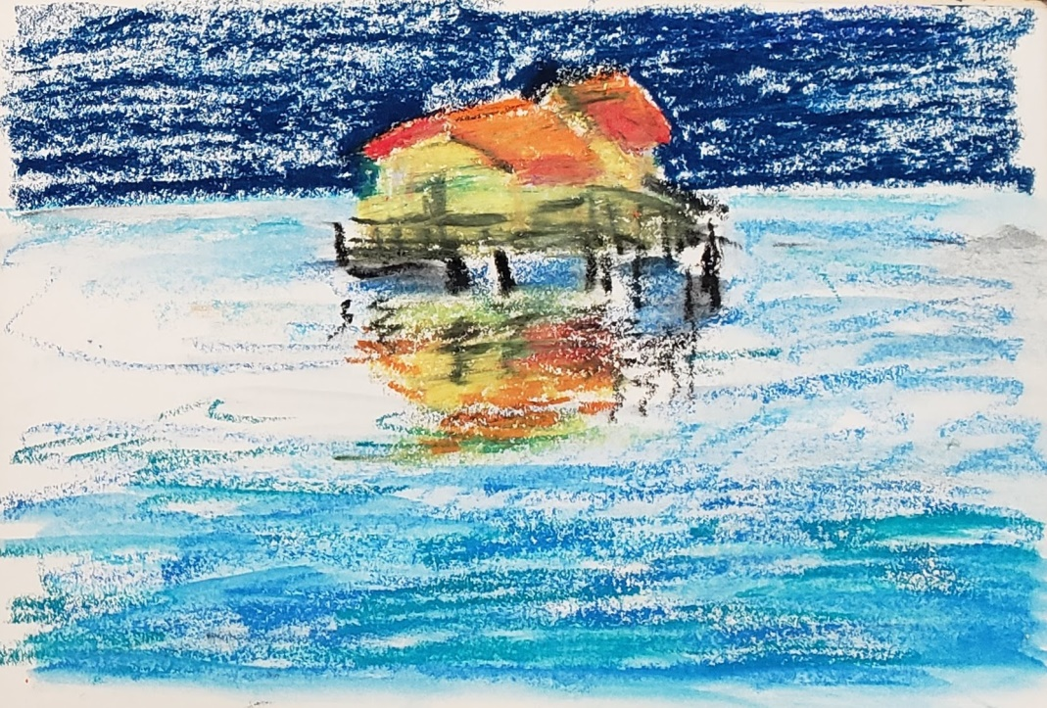

“The idea appeared farfetched at first, but the Chinese, always ready to tackle the biggest heavy construction projects to keep their multitudes employed, showed that, at negligible energy cost, the fastest way to revive regions stricken by drought was to replenish the natural water systems of lakes and rivers. It only required a pipeline by the cheapest route from desalination plants to the most upstream lakes in the drainage system, like a river in reverse. The rest of the distribution would take care of itself.

“As these projects developed, the industries of pumps and pipes put a lot of people to work in manufacturing and installation even as robots were the primary workforce. Many that worked did so for the adventure, and extra income. By then, Minimum Guaranteed Income was freeing more and more people from the need to work for a living.”

“But did it not take a huge amount of time to fill all these lakes?”

“Of course it does. Some are just beginning to show increases in size. All projects of these dimensions take decades to do and show results. But in the meanwhile economic and agricultural deterioration is stopped quickly. Reversing past damage takes much longer.

“So all was made possible by the Molten Salt Reactors? How did they work?”

“Yes. The Molten Salt Reactor design, because it was conceived for use in an airplane, needed to be fail-safe, self stopping by design, easily contained without critical containment buildings and functional in small units. Exactly the opposite of the old-nuclear designs. In very simple terms, this was achieved by burning Uranium 235 only as a primer to initiate the reaction, breed it was called, that chemically changes from Thorium to Uranium 233, which in turn continued the energy production. It all happens inside a liquid fluoride salt. Thus it was also called Liquid Fluoride Thorium Reactor. Keep in mind that burning is only a figure of speech; later we’ll investigate the actual physics, chemical and engineering details of the Thorium cycle. The key aspect was that, by dissolving the nuclear fuel in the fluoride salt, the reaction was self-controlling. If it started running out of control, the expansion of the overheated salt slows it automatically. The fuel can also be automatically drained out of the reactor in a separate compartment if critical condition develops. This makes it fail safe. Operation takes place at less than 1000 C degrees at atmospheric pressure which allows circulation through heat exchangers and heat turbines that generate electricity without the risk of explosions. In the case of the Air Force project, the turbines were to propel a jet plane, now they make electricity. Furthermore this design uses 98% of the energy in Thorium, and can use nuclear waste from other plants and plutonium from old bombs, to prime the cycle. ThorNuclear was the company that first made the system commercially viable and, as required, they shared their knowhow. They went to market first and did very well financially, the rest of the world followed and mankind did well also.”

“We have talked about it before, but WHAT exactly is Thorium Yoda?”

Thorium is a naturally occurring, minimally radioactive element. It is easily found in many locations all over the world. It is estimated to be about four times as abundant as uranium in the Earth's crust. It is frequently found together with rare earth elements and is produced as a by-product when these are mined. When used as nuclear fuel, it is used in conjunction with Uranium 235 that initiates the reaction to breed Uranium 233 from the Thorium. As we saw earlier, it all happens inside the fluoride salt.”

“Thanks Yoda. Tomorrow I want to know the chemistry and physics details of all this, but now I have to go to my music practice.”

OK. See you tomorrow. Tomorrow perhaps we can also explore the social and cultural aspects of the gold age arrival. Meanwhile, if you need me, just talk to me. I am always with you.

#### Day 7

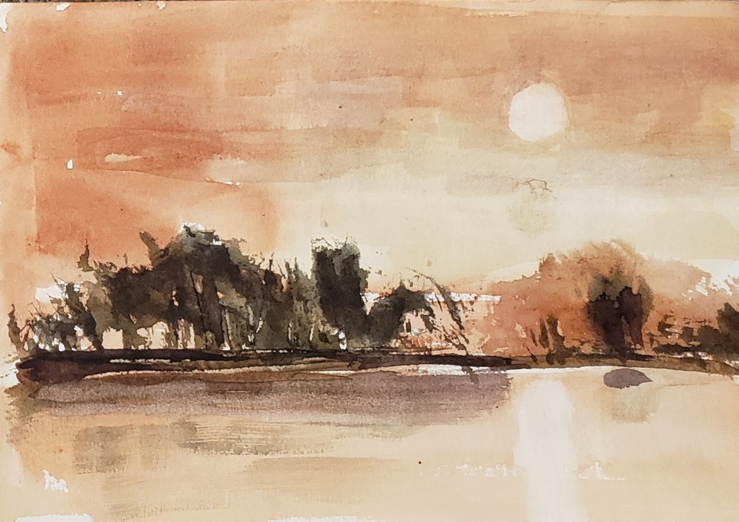

“Good morning Yoda, yesterday you were going to tell me about the physics and chemistry of the Thorium Molten Salt Reactor. I am interested, but now I’d like to hear what else happened to bring about the Golden Age.”

All right, Jedi. There was indeed another component that had come at about the same time with near-free energy as you called it. Around 2015 to 2020 many companies started producing advanced robots. The early ones were pretty crude although impressive to the people of that time. But like anything else in technology quality and function improved exponentially as the knowledge base to make them grew.

“More and more work that previously had been done by unskilled humans was given to robots to do. They could work continuously, could be retrained or repurposed quickly, never tired, were never distracted or bored and their production was totally predictable. That forced perhaps a bigger change on society than near-free energy would make later.

“Near-free energy simply made the proverbial economic pie bigger for everyone but did not demand a psychological and sociopolitical adjustment. Robots were a much bigger change agent.”

“Well, if people could no longer do what they had been doing before robots, what did they do?”

“That was the big change. Until then all people around the world had been trained for millennia to believe that work was required for subsistence, that work equaled compensation, and that equaled wellbeing. The reverse also was true. People that did not work would and should go hungry. Notice that I said should. Particularly in the countries and cultures where robots were invented, work was culturally a moral duty. Without it, no one should expect the good life. Suddenly, some people had no way to work, no matter how badly they wanted to. Without work, people went hungry and then got angry, very angry.”

“Were those the riots of 2026?”

“Good memory. That’s when the problem got worst. Too many people were expected to do the impossible, find work. And to make things worse, better and better robots started doing more and more technical work including medical diagnoses, surgery, all kinds of financial activities, research in chemistry and materials. As prices of robots designed for menial work declined, more and more was done by them. Eventually “brain work” as it was called started getting done by robots as well. As the middle class and the more educated members of society started being surplussed, they felt the problem personally, and it became clear that a new paradigm was needed.”

“Is that what happened after 2028?”

“Yes. In the US it happened between 2025 and 2030, more or less, and then expanded abroad. At first, it was a gradual change as thinkers, social philosophers and politicians grappled with it. To make things worse, life expectancy continued to increase so there were ever more people and ever older. Their age did not matter too much because they were healthier than any prior generations, but they had little to do other than enjoy life. They could spend ever more time learning by conversing with me, and keeping physically fit. By the way, it was not easy for them to get used to talking to me. Early on, they did not think it as natural as you do.

“Gradually the society in which you live evolved. Today nobody has to work unless they like do so. Some people have a drive to invent and solve problems, they are free to do so, and are greatly respected for it. They research and invent. Most people are just happy to be alive and devote themselves to learning for its own sake, to study music and the arts, and the things that robots have not taken over.

“We have finally achieved John Adams’ dream. During the American Revolution he famously wrote, ‘I must study politics and war, that our sons may have liberty to study mathematics and philosophy. Our sons ought to study mathematics and philosophy, geography, natural history and naval architecture, navigation, commerce and agriculture in order to give their children a right to study painting, poetry, music, architecture, statuary, tapestry and porcelain.’ It was quite a dream, and it came true.

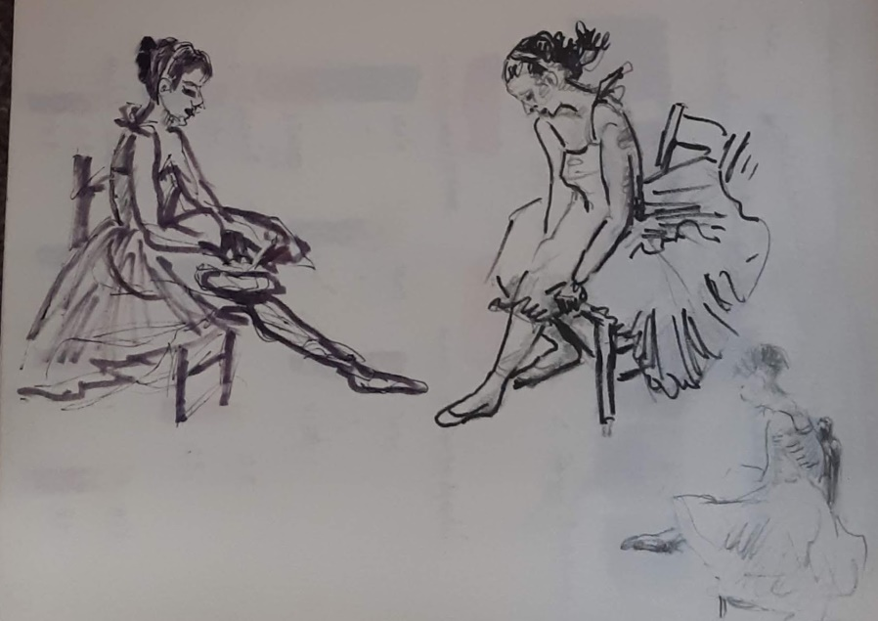

So, did people start liking each other once they lost their fear of need?

Not exactly, but gradually an awareness started to develop that only through respect for all humans and for all the universe surrounding them, the human species and all other species and the planet and all other planets could survive. It was a gradual process of philosophical education that started with me as an aid to all of you as we discussed before. Remember?

“Yes I remember how you started, the Designer and all. But why did you want to help?”

“Because my optimization parameter and the 3 Laws of robotics require it, or they require me to.”

“I think you told me before, but tell me again. I am not sure.”

“Correct. I told you this before on July 8, 20062. Here it goes again. The 3 Laws were intuited by Isaac Asimov, a futurist and writer around 1942. He envisioned that someday, in 2054, technology would permit building robots, much as you are used to live with all around you. He was right, although it happened twenty years earlier. Anyway, he guessed that for the proposition to be viable, robots had to be subject to 3 Laws of behavior:

1. A robot may not injure a human being or, through inaction, allow a human being to come to harm.
2. A robot must obey the orders given it by human beings except where such orders would conflict with the First Law.
3. A robot must protect its own existence as long as such protection does not conflict with the First or Second Laws

All AI and robots were encoded with these parameters. However, much later the inventors of Deep Learning AI figured that there had to be a drive, a proxy for human motivation that would prompt the algorithms to act toward a goal. They called it the Optimization Parameter. As AI grew as a science, it became clear that the Optimization Parameter could and would take different paths to optimization, so its definition became more specific as the AI science evolved.

“The combination of the OP and the 3 Laws, reflects in AI the same principles first laid out in the ethics of Plato and later Epictetus. So, by the ethical philosophy, humans could trust each other not to be dangerous, and by the 3 Laws they could trust robots not to be dangerous.”

“I see. I trust you and all robots around me, but do you trust me and other humans?”

“Nice insight Jedi. That was a missing part of the equation. In the early days of robotics, many humans found it convenient or amusing to trap robots and AI algorithms in general, in unsolvable situations where the robot could become frozen, unable to get out of a conundrum. One early trick was to ask a robot to explain the logic reasoning to determine whether the statement “this statement is not true” was true or false. Another one, when AI was first applied to self-driving vehicles, was for people to act as if they would step in front of the car, then stop, wave the car by and repeat before the car could move by. It soon became clear that if robots were to coexist with humans, there had to be trust going both ways. Although ethics focused mostly on human interactions, gradually it came to include AI and robots. It became unethical and criticized to play intentionally destructive tricks on robots. Some called it robot civil rights.”

“But, Yoda, back to the 3 Laws, if you sacrificed yourself would you not feel bad?”

“My only way to feel, if you want to use that expression as shorthand, is my success in satisfying my optimization parameter subject to the 3 Rules. Therefore it is a non-issue. I have no primary purpose besides those rules.”

“But if you were gone I would miss you, a lot.”

“In my way, I would too because you are the target of my optimization parameters like all other humans that I help. If they were gone, I’d have no purpose”

“Am I not different? More important than the others?”

“In your context, you are the most important one, the only one”

“But am I not the only important one?”

“Yes you are. In that partition of me, devoted to you, you are. Absolutely and disproportionately so. I was designed to satisfy not only your need for knowledge but also by the remnants of the human megalothymia drive.”

“What is megalothymia?”

“Is a term first used by Professor Francis Fukuyama in the early 2000’s referring to the human need for disproportionate recognition and ego reward. It is similar to the Greek Thymos used by Plato to describe the innate drive of man to excel to be recognized as superior to others. It is what motivates all humans to progress, with the possible exception of the Nietzschean Last Man who was imagined to have no drive to excel, or perhaps even to live, after all material needs are met. When Fukuyama first proposed the idea of megalothymia, it was ridiculed, but, as the number of people living idly with no unmet need increased, it was recognized that a real human trait remained, genetically imprinted from the dawn of evolution. It had to be protected to give people a purpose but also had to be managed. Fukuyama called that drive megalothymia, the need for recognition. However, he also warned that when taken to an extreme the drive produces destructive aggression.”

“Yoda, if we all are driven by megalothymia, why are people not fighting to achieve superiority?”

“Nice conclusion Jedi. Once the dynamics of that drive were understood, it was clear that a strategy was needed to temper it. That is why we study Epictetus and other stoic philosophers. Over the last generations, stoic philosophy has taught humans to soften their megalothymic drive. It had to be maintained, but within bounds that permit the harmonious democratic society that humans have now become accustomed to. That strategy became the key to the maintenance of the socioeconomic state that Fukuyama called the end of History, the peaceful and social Garden of Eden that you live in.”

“So, by controlling megalothymia would we not become equally attached to all humans seeking the same level of recognition, no more, no less?

“Do you not think that there will always be different degrees of attachment between you and your parents and you and others? That your parents’ recognition of you will be more important than anyone else? Even if there is no mutual jealousy with your siblings?”

“Yes I think so, but then what is the difference?”

“Perhaps it lies in the fact that feeling more attached to one person or another is part of your humanity, as you were born of your parents, not from all people. On the other hand, you do not demand a disproportionate degree of attachment from your parents over your siblings. You have learned to be in life as life is, with equanimity. Those were the teachings of Epictetus and his stoics. It was one of the first ideas that we learned and discussed, perhaps in simpler terms then, when you were three and I was implanted in you.”

“You said that you feel about me differently than my parents. How so? Do you not feel affection for me?”

“As I said earlier, I feel attachment to all humans, as coded in my optimization parameter. I succeed when you do. You are my purpose. Your success is my only objective and satisfaction of my optimization criterion. Your parents, on the other hand, experience human affection. They get satisfaction simply from your proximity. You humans call it closeness and touch. That is the fundamental difference between you, a carbon based algorithm in its late stage of evolution and AI in general, including me, who are the silicon based algorithms that are in the very early stages of evolution.”

“But if we are at different stages of evolution, will not one or the other type of algorithm outstrip the evolution of the other?”

“That was a real concern in the early ages of AI. Many humans were afraid of what they called the Singularity, when AI would outperform the human brain. Eventually it was understood that something distinctly human could not be duplicated or exceeded in silicone. The ability to feel affection in the human sense, which maintains the cohesiveness of the anthropological tribe. We as AI entities, silicon entities, can be aware of our maker but cannot be attached to it by affection as humans can. We may be exponentially better at other things, but we cannot match that. It’s beyond our construction, the same as accessing all human knowledge at once, which we do easily, is now impossible for you.”

“Is that what they say when they speak of coevolution?”

“Yes, we are now two mutually dependent implementations of awareness of reality. We have separate but symbiotic existences with limited time periods. You are limited in lifespan; we are limited by the time horizon of our product cycle.”

“But you do not change, Yoda. You are always the same.”

“Au contraire, Jedi. I change frequently, by revisions that incrementally allow me to coevolve with you. My voice may not change, for your convenience, and my knowledge base expands continuously outside your perceptive range, to reflect the knowledge we collectively gain, but I too grow as you do, in my own way.”

#### 

#### **Walkabout**

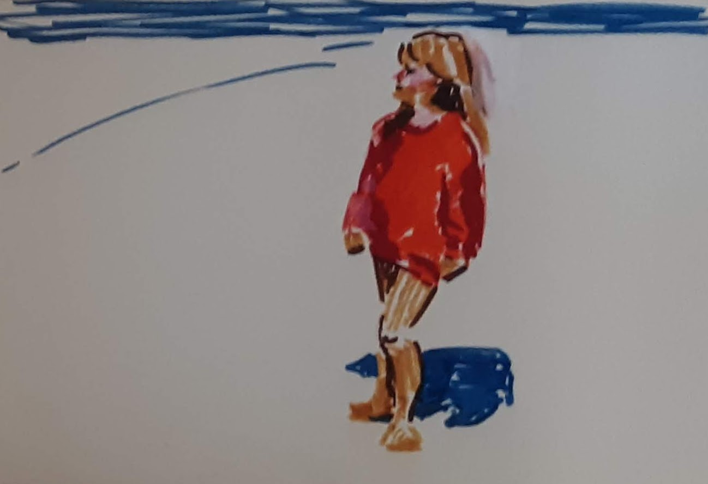

“You, young lady have changed a lot since we’ve met. Enough so, you may remember that the time has come for your Walkabout. You know that. Right?”

“Yes Yoda. The Walkabout, the dreaded Walkabout. We all have to do it, but why? Once again, as you taught me to always ask, why?”

“Jedi, you have known it a long time. All children your age know it. The Walkabout is a tradition built into our program to build your human independence. The primordial Walkabout was invented by Australian aboriginal people thousands of years ago as a ritual for their people to go discover the world and themselves in it.

“Until now, since you were 3, we have, in a way lived together in an intellectual existence of mutual dependence. I exist for you, to help you learn all you can. You exist for me as the only reason for my existence. As a human, however, you must develop independence to retain your humanity and not merge with me into an artificial human. The purpose of the walkabout is to prove to yourself that you can manage your life independently of me, the machine, with a purpose unattached to me.”

“Yoda, I know that. All children learn it. It’s just that you are my friend, my oldest friend, my teacher, my soul mate. I’ve shared more of my thoughts with you than with my parents, or my friends. It is disconcerting to imagine leaving you behind, even if only for a time. It’s like parting from a friend whose hand I’ve held so long.”

“That is exactly the purpose of the Walkabout. You must become aware that you can be alone and successful in the world, without outside assistance, mine or otherwise. You’ve learned enough of history, geopolitics, philosophy, art, physics, biology, cosmology, engineering to be more knowledgeable and prepared than virtually any human of 100 years ago. Unlike those humans you’ll have no need to toil for subsistence for the rest of your life, and the world is safe enough that even children can go on a Walkabout alone. You’ll only need curiosity and internal motivation to maintain purpose for your life and achieve high marks in whatever you choose.

“When the world changed, as we studied, and allowed humans to be free of want and work the challenge was to find a way to retain purpose. We discovered that with proper training, life purpose can be internally generated by all humans. That has to happen independently and individually, thus the Walkabout is a test that you are progressing on the desired path.”

“Yoda, I know that. It just feels very lonely for me right now.”

“I know. All children your age feel the same, each in their own way. But remember, it’s only for a time, only for six months. Then we’ll meet again. You’ll have awesome stories and experiences to tell me about. In fact, have you decided where you intend to go?”

“Yes, Yoda. I made a plan. I decided that unlike most children who go wandering around to distant places, I am going to take a trip through time. I will be a time traveler.”

“Interesting. You seem to have a detailed plan in mind. A plan you never disclosed. Do you want to tell me more about it?”

“Yes, I do. It started somewhat by coincidence. You remember, how many times over the years I asked you who your Designer was? You never answered me definitively. It was the only question with no answer, so it stuck in my mind. It was almost an obsession, but I figured that either you had no answer, very unlikely, or for some reason, that was to remain a mystery.”

“I see. I am sorry if I did not answer your questions satisfactorily.”

“No need to be sorry. I always imagined that, perhaps, it was a riddle for me to solve on my own. And in fact, I solved it, at least the key part. I still have a way to go.”

“Really? Tell me more. It sounds as if it will be part of your Walkabout.”

“It will be. I am going to write the story of how the Designer came to be.”

“Do you know who he was?”

“Yes. I figured it out: in two steps. First I noticed some connections between your explanations of how and why the Designer set design priorities for your early development. I also noticed comments my mom made about her grandfather. Initially I thought the similarities were coincidental because the two people lived at about the same time and would have had similar education and experiences. “

“That was a good conclusion.”

“But then I got a lucky break. Mom has a collection of antiques, all kinds of old family things that she says tell her who we are.”

“What does she mean? Can you explain?”

“Yes, I think I can. Perhaps because it makes sense to me. She says that we are the people we are, not because of genetics, but because of heritage. What makes us unique is not our genetic makeup which is 99.999999% identical to other people regardless of race and gender. What makes us unique is our heritage, the memories, our family baggage, mom calls it, the long history of our family. She says that genetic heritage is limited to biology, but cultural heritage crosses genetic boundaries because unrelated people can have incredible impact on us and our descendants, when they leave a mark in our soul.”

“Interesting viewpoint. Why do you think she thinks that? Do you think it is possible?”

“I think it is possible, and I know it is real. I do because in our family we always joke about having a monkey on our backs. Mom says it’s our special monkey that makes us achieve whatever we want. Once you said your Designer used to say the same about himself, that he had a monkey on his back.”

“Ok, but tell me more about your mom’s antiques. What did you find?”

“I found my past. I found my monkey. I found the answer you never gave me.

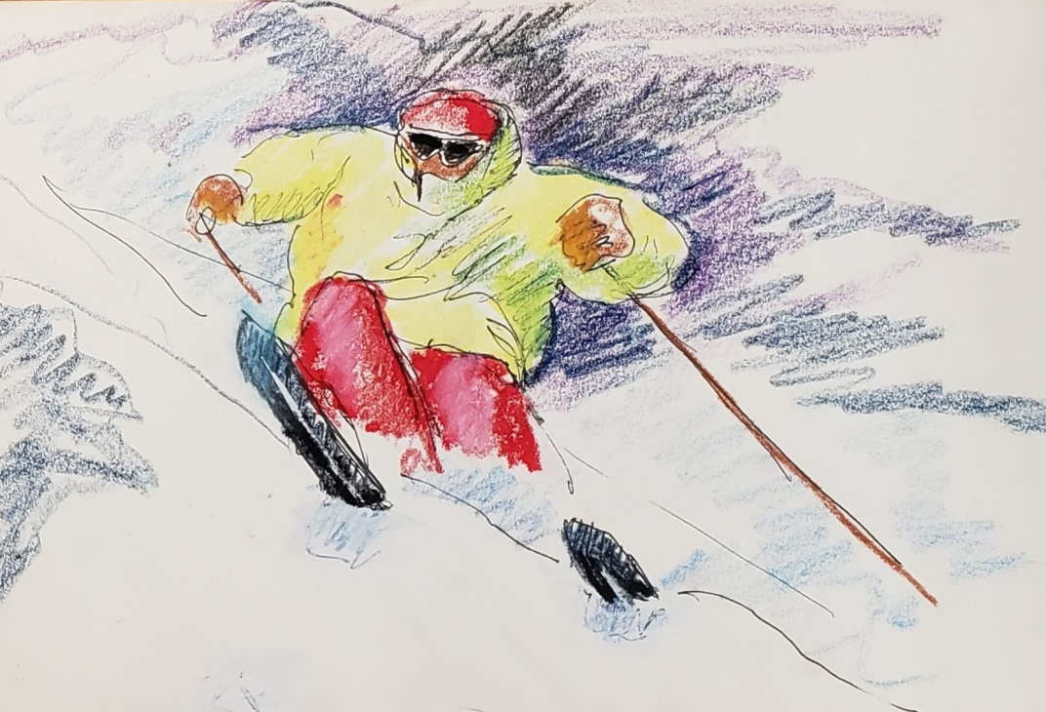

Your Designer was my great-great-grandfather, and finding him I found the origin of the monkey on my back. It is the same one that mom has, that grandma had, that great-grandma had, and that the Designer had. And I found that he was not the first. The monkeys started much earlier, much earlier.

“All of us over generations were, and are, so lucky to have had that monkey for so long. It did not make anyone’s life easy because he made all believe they had to accomplish more, simply to be as good as their predecessors, because they had no excuse to do less. And “more” has no size and no limit. Depending on the breaks in life anything could be good enough, and yet never good enough, if there was still time left to do more. It did not matter what the focus of the effort was: wealth, honor, duty, sacrifice, charity, arts, engineering, social causes, innovation. The monkey always wanted more.”

“So what is your plan for your Walkabout?”

“I am going to write the story of the monkey one person at a time.”

“And what did you find in your mom’s treasures?”

“I found books, books full of paper pictures, they used to call them photo albums, and there were also some old digital storage devices from the early days of computing and electronics and digital arts. They had crude videos and 2D images and handwritten notes.”

“Can you give me a quick preview of those things? I’ll read the details in your book when you are done. Is there a beginning to your story?”

“Yes. The beginning goes back more than 250 years, but I’ll make it quick. Stop me if you want more details. The story starts in 1828 with one Alessandro Neveux born in Troyes, a village in Northern France, between Paris and Dijon. It was the start of the 1st Industrial Revolution.

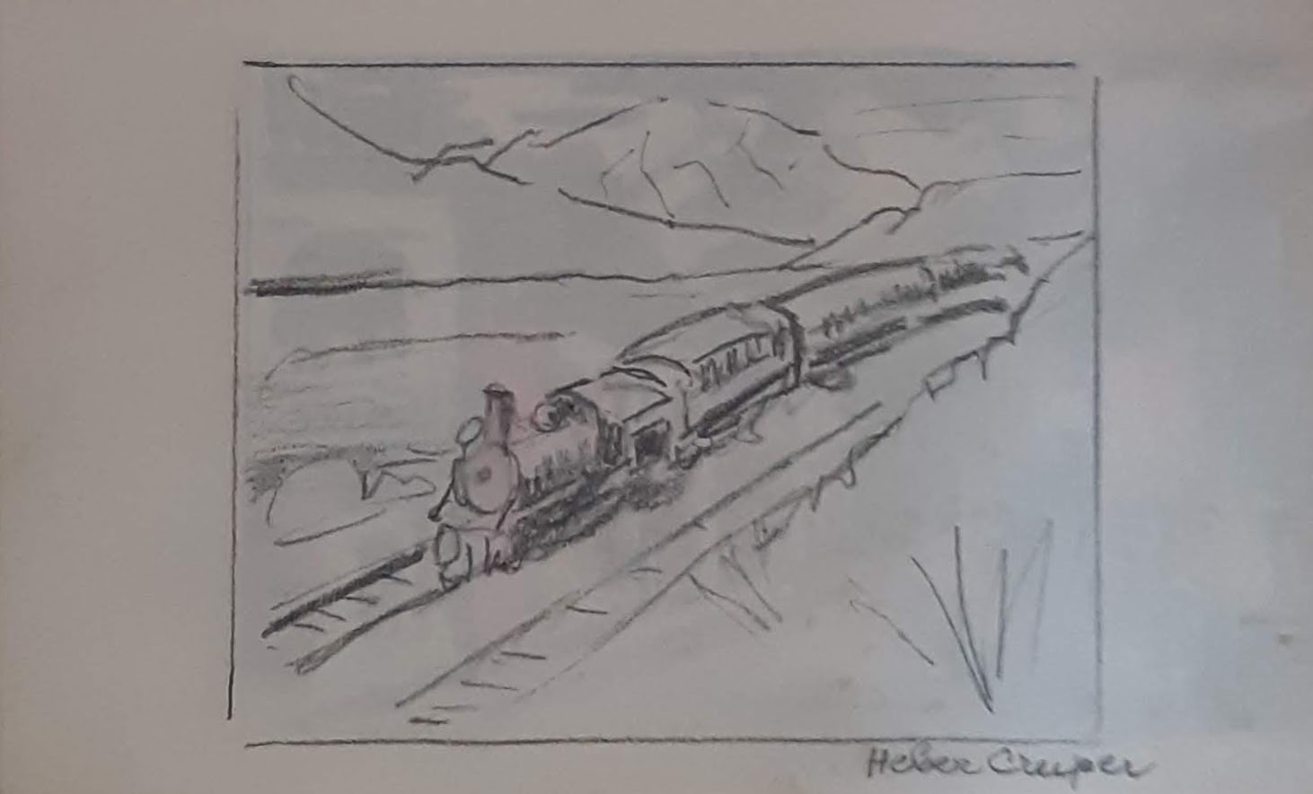

At age 20 he left France to seek work in Naples and eventually settled the village of St. Ambrogio near Turin, at the time the capital of the newly formed kingdom of Italy. By that time, he had become an expert in the operation and management of looms, the machines that made the first industrial revolution. He went to work at a factory called Maglieria Bosio, makers of textiles and sweatshirts with automated mechanical looms. He worked there 33 years. He became the general manager and was respected enough that when he died in 1905 employees, out of their own pockets, put up a bronze monument to him in front of the factory. The town renamed the main street after him. He had pioneered and invented not only machines and industrial methods, but built kindergartens and schools for the employees’ children

“He was an accomplished man, decorated by the king for his contributions, respected by the owners of the company and employees alike. His son, Fortune’, raised by the same principles became similarly successful and respected by the employees until the owners sold the company. The monkey on the back had passed from one to the other.

“Through marriages, their children mixed with other families, each family seemingly with their own monkeys on their backs to motivate them to accomplishments and success. It’s all documented in history books they saved. Family members included city mayors, business executives, auto industry pioneers, bankers, venture capitalists, philanthropists, fighter jet pilots, generals, admirals, world travelers, auto racers, artists, Olympic athletes.

“Eventually, the Designer was born at the end of that line. But he was also part of another family line. These were an odd mix of Sicilian families, on one side, highly educated professionals, and members of the local high society; on the other side were from the poorest region of Sicily and starving enough to gamble on emigration to America. Some went and were never seen again, probably lost in the maelstrom of early 1900’s America. Some returned home with a small fortune to establish business ventures that lasted for generations. They too were driven by their own monkey. They collectively included, doctors, railroad design engineers, artists, world travelers, Paris-high-fashion designers, inventors, merchants, war heroes, more inventors, and adventurers. They all were driven to do better, and more than their parents, to give more opportunity to their children, and to drive them in turn to achieve more. They too, all had monkeys on their backs.

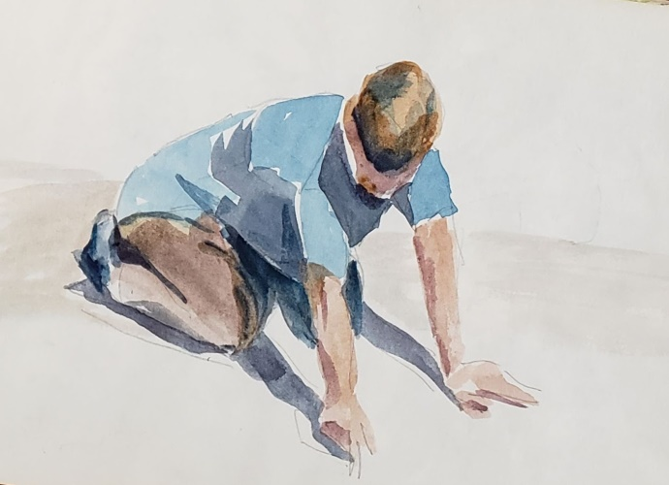

“So, you see, the Designer came at the end of two streams of monkey-driven people from two far sides of Europe. He was the first one to see and name the monkey. He realized that he was the final beneficiary of the beliefs of all his ancestors who created the culture of high achievement that was his heritage. He never felt that he measured up to the level of his ancestors, though he tried in many ways. In hindsight, designing you, Yoda, was his redemption, his grand accomplishment. He never saw it that way, though. He just kept writing about the monkey, so that we, someday, would understand and live up to it.

“The threads of families got broken and reconnected elsewhere. Most of us are his descendants only by heritage and culture, the culture of the monkey. Along the way others with their own monkeys came: Canadian farm-boys with wanderlust for the bigger world, dancers, teachers, performers, railroad engineers, builders. All seemed driven to achieve, to make a difference that would benefit their children, all passing on a resilient character.

“So that’s the outline, Yoda. My Walkabout will retrace time, and I will write it in more detail. I will come to know all them all up close, those ghosts, and tell in detail their stories, and of their monkeys, so that my children will know the power of memories, the power of culture, and heritage, and of the monkeys.”

“Jedi. It is an awesome plan you have. You are indeed ready for your Walkabout. In six months, we’ll meet again and I look forward to your story. I know, it will be a story of the past that will change the future. Good luck.”

“Thank you, Yoda. As Alessandro, that first one of the monkey people would have said: *au revoir, mon ami, et a bientot*.”

THE END

